

**117. Step 01 - Getting Started with S3 - AWS Object Storage**

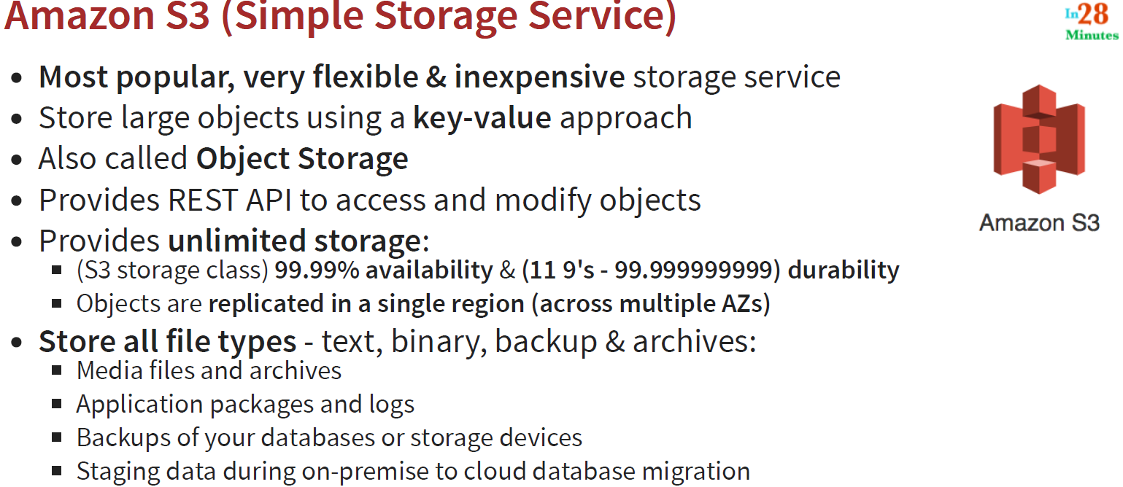

**119. Step 02 - Creating an S3 Bucket and Exploring the UI: Demo:**

Go to AWS Management Console > Search S3 in the search box

Once the S3 page comes up we can create the bucket to store the objects.

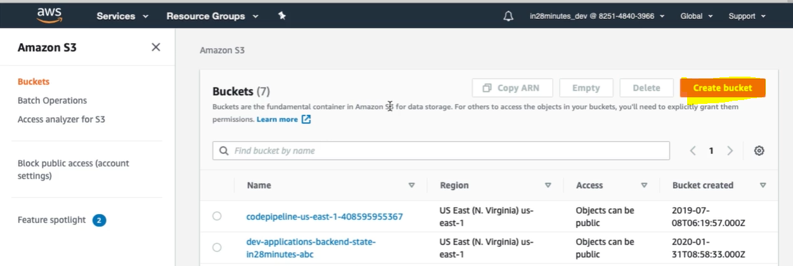

Buckets are fundamental container in Amazon S3 for data storage. For others to access the objects in your buckets, you will need to explicitly grant them permissions.

Let’s create a new bucket by clicking on [Create bucket] button.

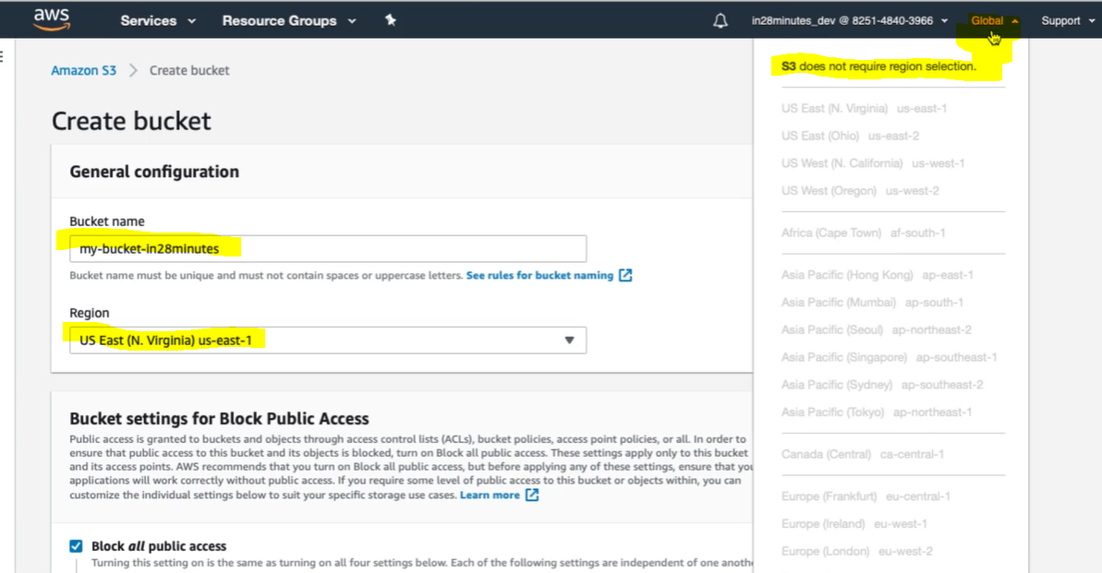

A bucket name in S3 should be globally unique, and it should not be only for our AWS account but should be unique in the global namespace across all AWS accounts. Here the bucket we will use in the REST Url.

The next thing is to select the Region, but since S3 service is a global service so once you logged in, in the particular region then you don’t need to select the region because we don’t get any option to select region because all the regions are disabled.

The next thing is provide public access to the bucket. But for now let’s go with default selection.

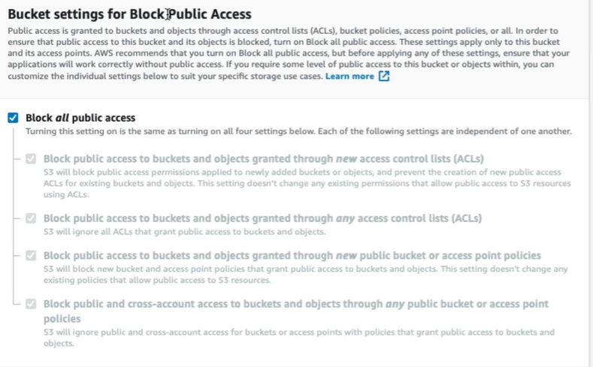

Now the next thing is Advance Settings

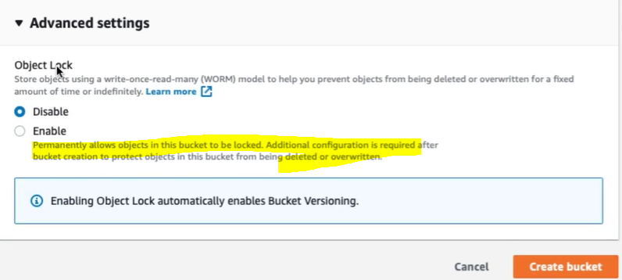

There might be the case of that some of the company do not want to delete the object so to prevent object from being deleted or overwritten for a fixed amount of time or forever let’s check on Disable radio box.

And if we select Enable then automatically it enables Bucket versioning.

Now let’s click on button [ Create bucket]

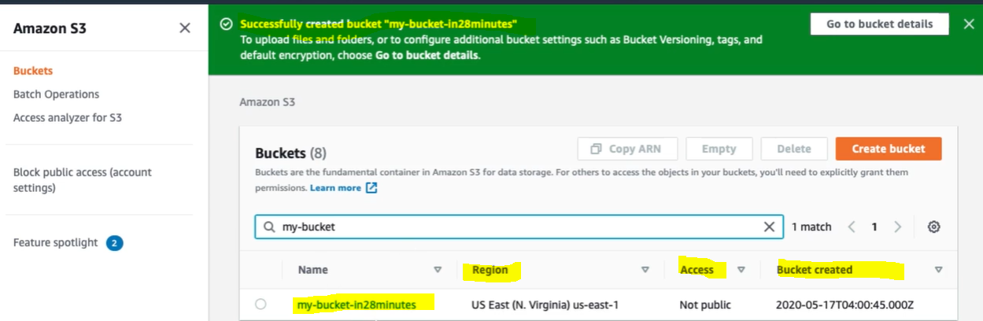

So finally bucket got created with its name, Region, Access (Not open to public) and Created date and time.

Now let’s click on bucket name and go inside the newly created bucket.

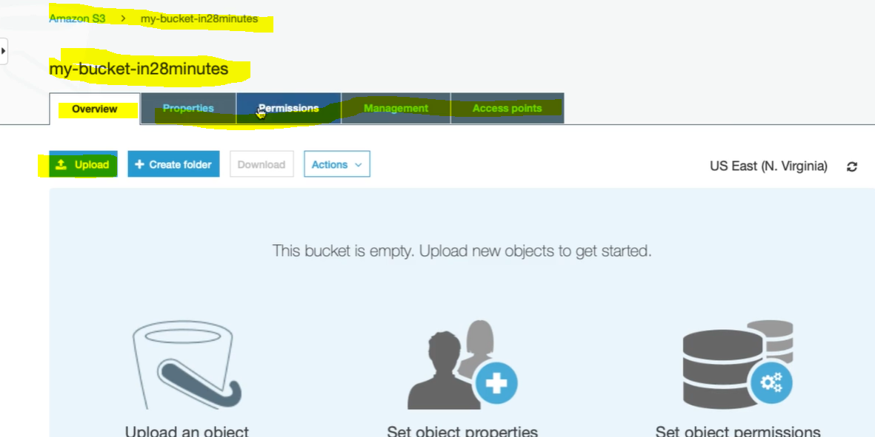

So here we can see the several tabs, where we can set the properties, permissions, Management (lifecycle), Access Point (providing access to other services).

Now let’s upload the files and folder (Objects) in the bucket. Click on upload button:

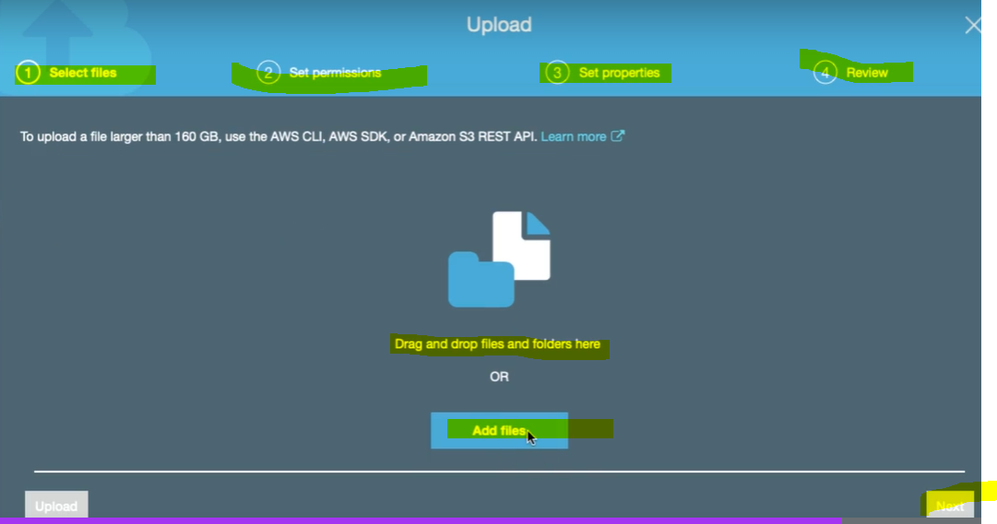

So we can see that uploading files involve four steps: 1- Select files: 2- Set Permissions : 3- Set Properties: 4- Review

**2- Set Permission:** In this step we used to provide the access to the files based on requirement like (do we need immediate access of the file after upload or after 24 hrs or week or months). So to provide access we would have to select Storage class designed based on the condition given in the below image. Here we have four kind of storage class:

1. **Standard : 2- Intelligent- Tiring: 3- Standard IA: 4 One- Zone- IA**

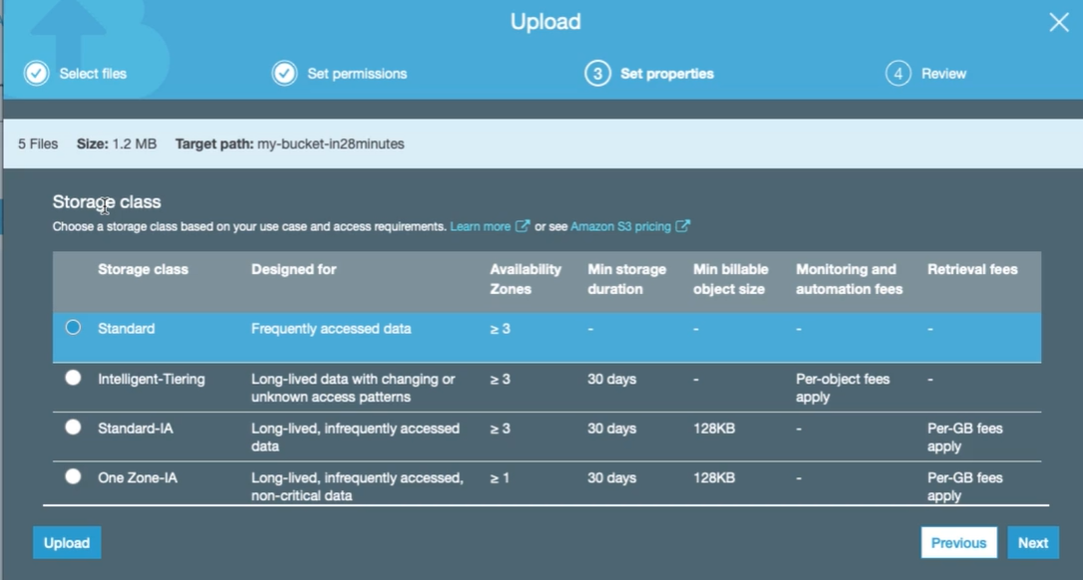

Click next > next > next

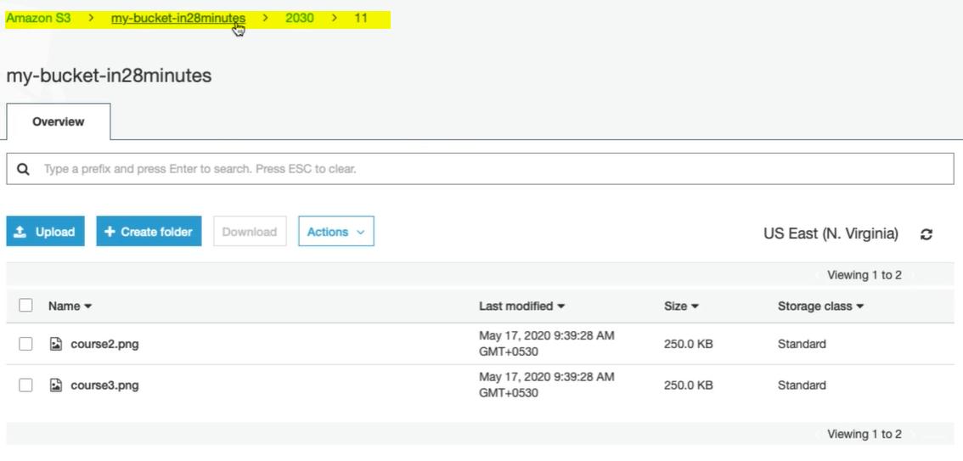

And finally we could see the files and folder inside the bucket.

**120. Step 03 - Understanding S3 - Objects, Buckets and Key Value Pairs**

Let’s go inside the bucket and click one of the stored file.

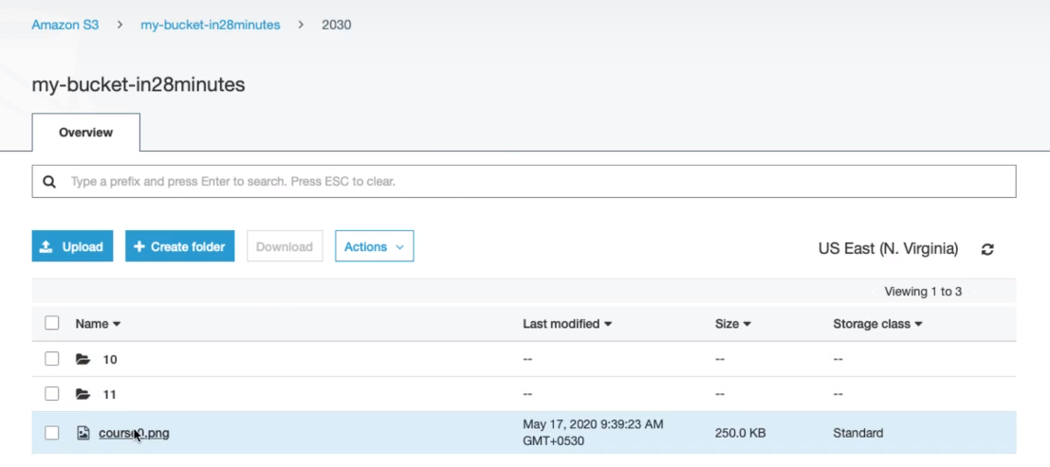

Clicked on cource0.png and let’s see further:

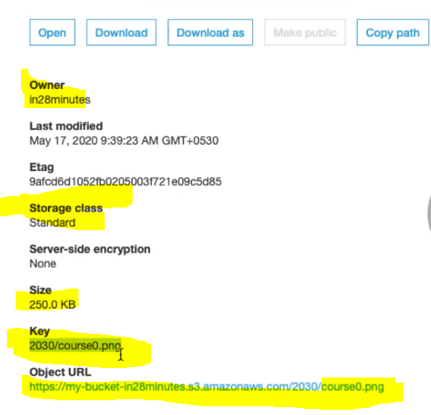

And here we can see the key associated with Object file (cource0.png). So each object is stored in the form of key and value (image).

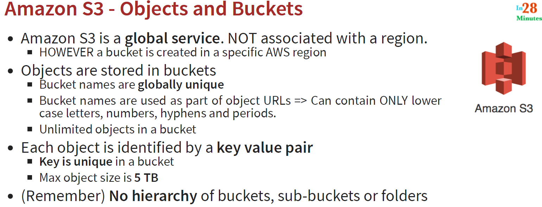

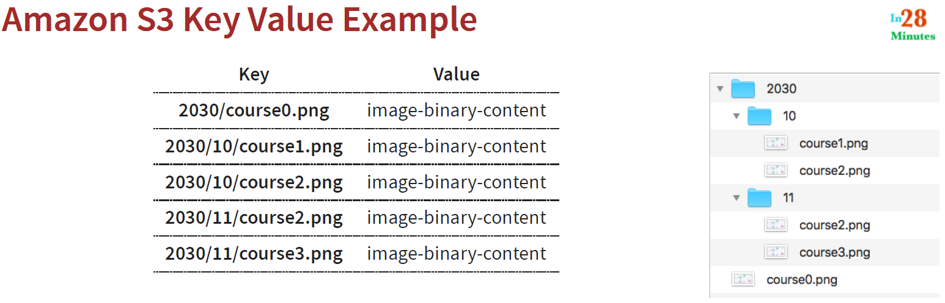

So for each value (object) there we have key associated with it and they do not make any kind of hierarchy of buckets, sub buckets or folders like we could see in case of windows and Linux.

**121. Step 04 - Playing with S3 Versioning**

In the previous step we have talked about the overview of the bucket where we have uploaded the files and folder in the bucket and we saw it get stored in the form of key-value.

Now let’s talked about another feature “**properties**” of the bucket.

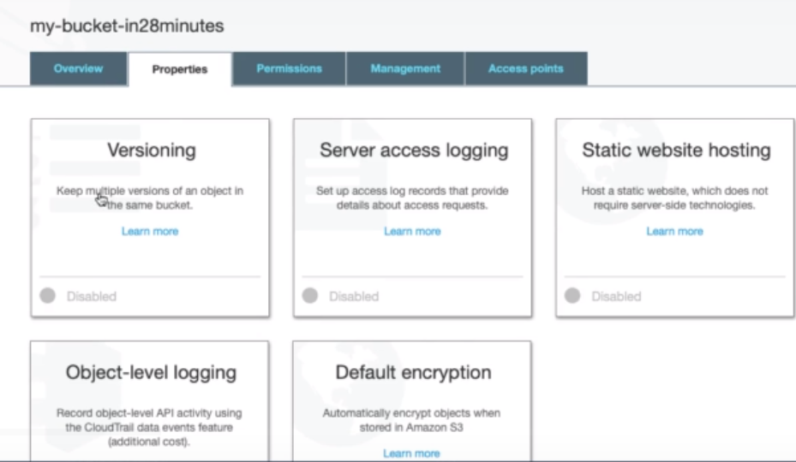

As per the above image we could see several properties at the bucket level.

**Versioning:**

Help in tracking and keeping multiple versions of an object in the same bucket and protects against accidental deletion.

|  |  |
| --- | --- |
| Versioning is optional and is enabled at bucket level. To enable versioning just click on Disabled link and Enable Versioning from there.  Click on Save:  Once we enable versioning, we can just suspend it and we are not getting any option to delete the created version. |  |

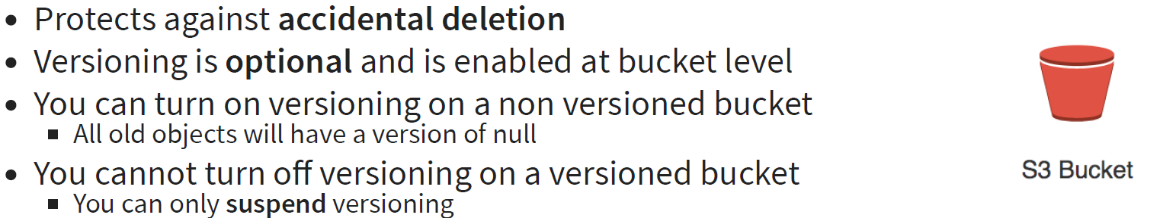

**Note**: Once we enable versioning, if we upload the same file or object at the same place then a new version will be created of the same file along with the old version of the same file i.e. if we overwrite any of the object then a new version will be created with same object. Once we suspend the versioning and now if we try to overwrite the same object then in this case now version will be created.

**122. WARNING! BILLING ALERT! Do NOT Enable Access Logging For Your Buckets**

WARNING! BILLING ALERT! Do NOT Enable Access Logging For Your Buckets

In the next step, **DO NOT Enable Access Logs**For Your Bucket if you want to keep your storage within FREE TIER Limits

Here's my S3 bill while recording the course:

- S3 Replication - $0.005 per 1,000 PUT, COPY, POST, or LIST requests. 1,021,683.000 Requests$ => 5.11

- $0.0025 per 1 million objects listed in S3 Inventory. 3,706,745.000 Objects => $0.01

**123. Step 05 - Logging S3 Access Requests**

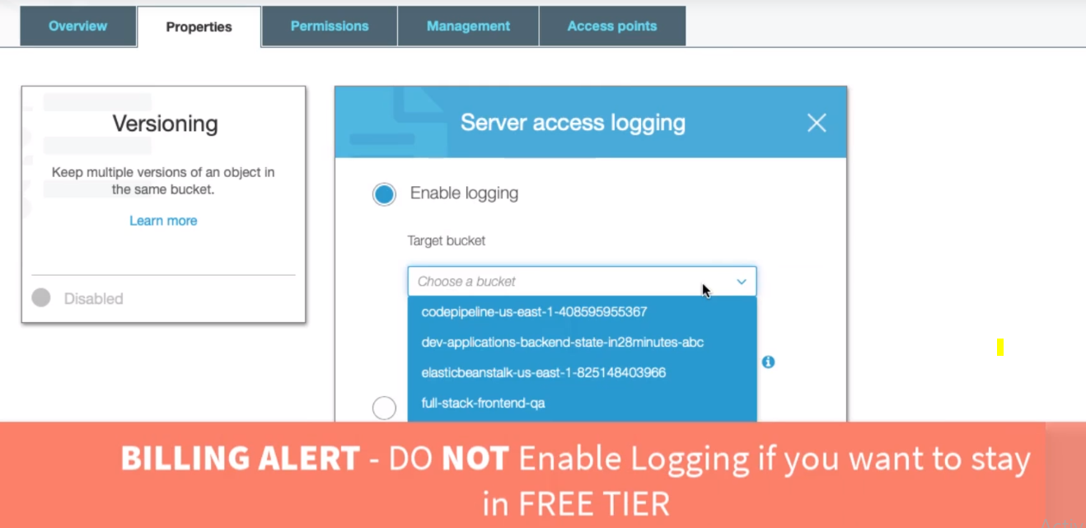

|  |  |
| --- | --- |
| * Enable the logging * Select the Target Bucket for which log needs to generate * Provided the Target prefix inside which logs file will be generated * Save * Once enable the log then we have to provide the permission for the log to be generated from the permission tab |  |
|  | |

So here in this step we have enabled the logging and provide the permission the log delivery to read and write.

It might be possible; it would take few hours time to generate the logs.

**124. Step 06 - Creating a Public Website with S3**

In this step we will look to host static website using S3. This is one of the most useful property which is mostly use in S3.

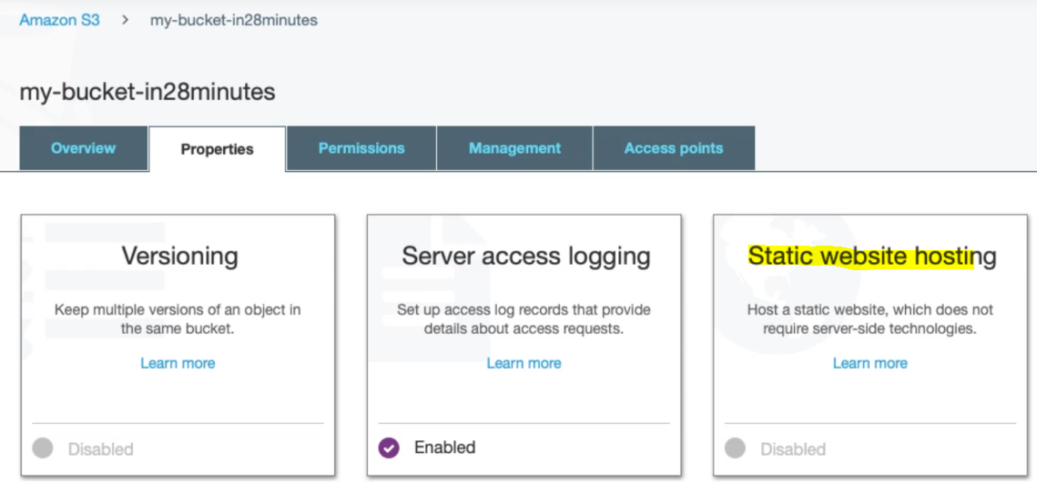

|  |  |
| --- | --- |
|  | Provided the index.html in the index document.  Click save.    And Static website hosting has got enabled.  Now we have to upload the content and also need to give the permission for public access. |

**Upload the Content to the static website:**

Go to the Overview tab of our own bucket > Click on upload button > Select all the content related to the static website and drag into the bucket.

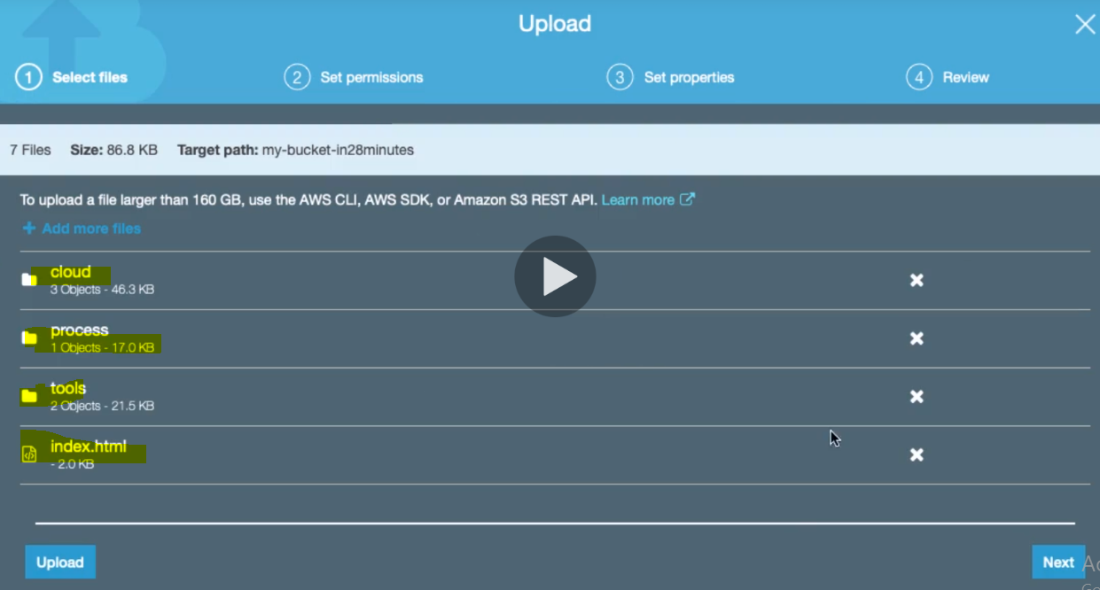

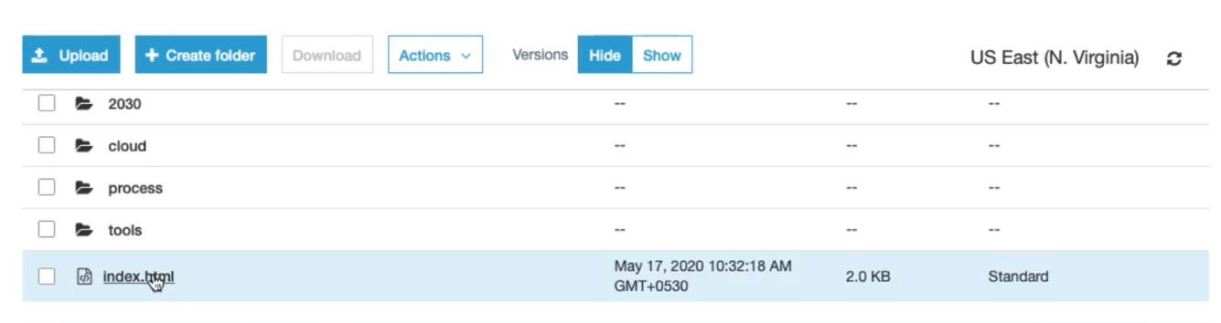

So we have uploaded all the content related to website.

|  |  |
| --- | --- |
|  | Now if we try to access its index.html page then we will get permission denied. As we can see below.    So to get the right content we have to give the permission from the bucket level. |

**Providing Permission to Static Content of website:**

1. Go to the permission tab of the bucket:
2. The first thing that we have to enable is that its public access. Right now its public access is On So let’s make it Off.

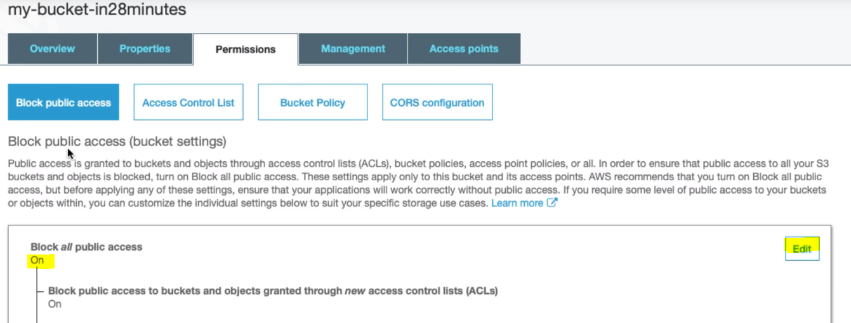

Click on Edit and uncheck and save it again:

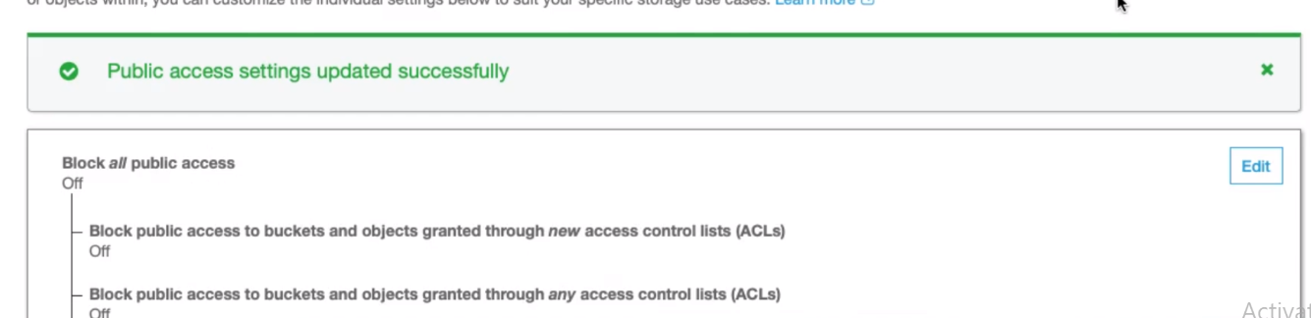

So we have enabled the public access but this is not sufficient we have to provide one more access:

1. Go to Permission Tab > Go to Bucket policy > configure the bucket policy here:

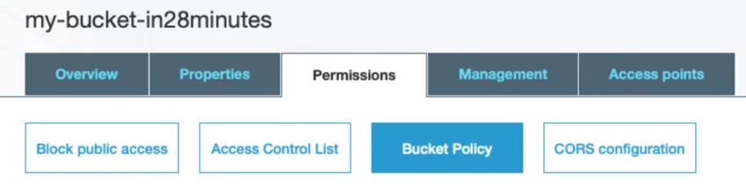

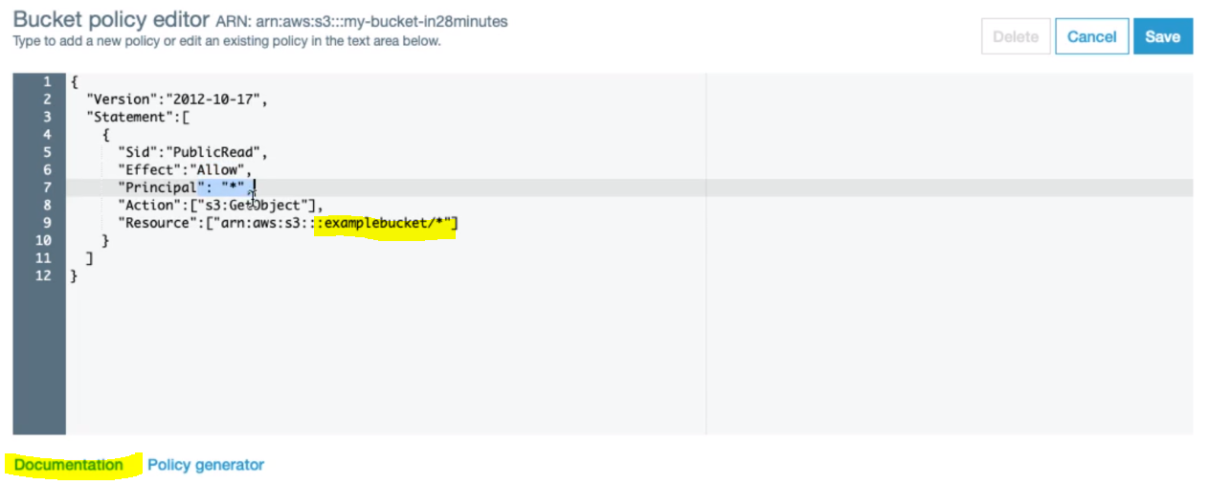

The above content format we can take from the Documentation: Now here in the content let’s change our bucket name inside the Resource: which is right now showing examplebucket/* .

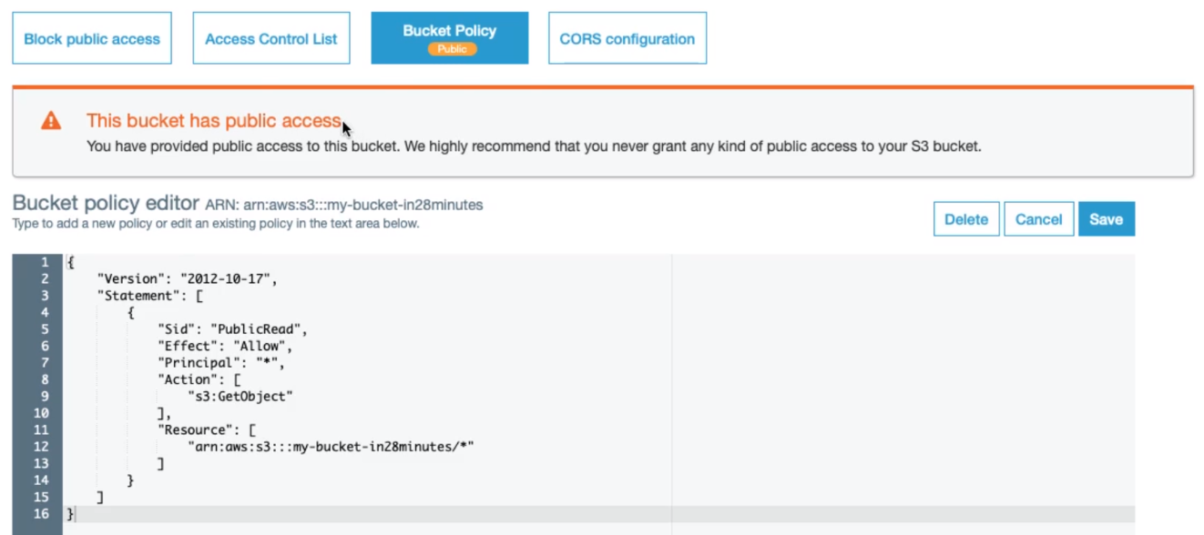

So now this bucket has public access: Now if we hit the URL then we will not get access deniend:

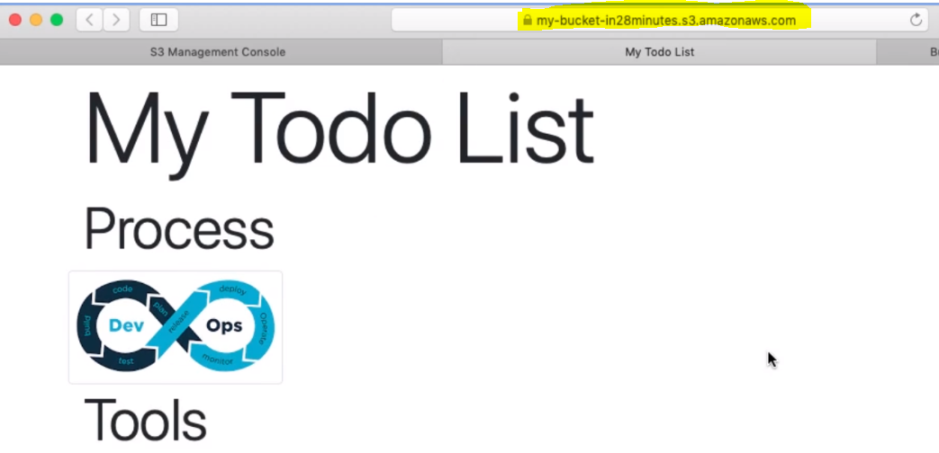

So in this way we can create and host the static website using S3:

So In-short:

**125. Step 07 - Quick Review - Creating a Public Website with S3**

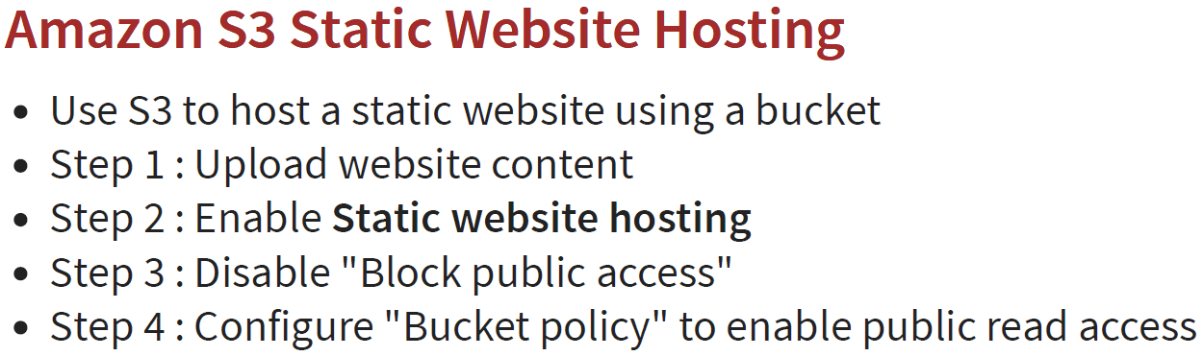

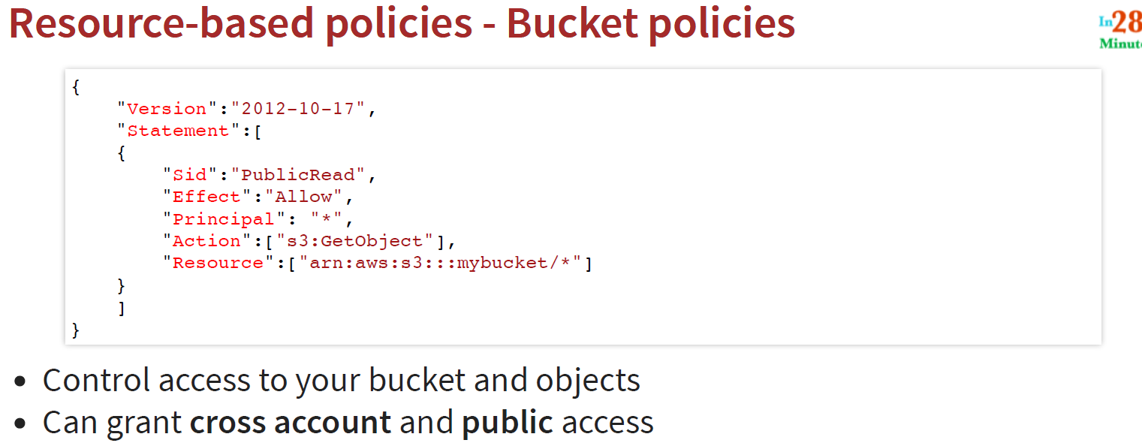

**126. Step 08 - Exploring S3 Object level logging and Encryption**

Let’s talk to another feature of the Property Tab: Object Level Logging and Default encryption.

So if we want to log all the API call, which is happening with the specific bucket, then we can turn on object level logging.

|  |  |
| --- | --- |
|  |  |

So whenever any activity happens in the API then it will be recorded in the CloudTrail. Now let’s talk about encryption:

**Default Encryption:**

* It is one of the most important features comes into picture whenever we are storing data into the could
* We always encrypt the data when we want to store the data into the cloud
* In S3 three are basically multiple option present
* Default is **None**- means no encryption
* So to encrypt the data either we can choose **AES-256** or **AWS-KMS**

|  |  |
| --- | --- |
|  |  |
|  | * Here KMS is KEY Management Service * We can create our own encryption key here and can confugure with the Key available in the drop box |
| This is the default Key direclty managed By AWS and can be Use as Server Side Encryption with Amazon S3 Managed Key (SSE- S3) | We can alos create policy, like if someone does not encrypt the data then S3 can reject the reqeust. The best practices is to always encrypt the data while storing in the cloud. |

**127. Step 09 - Exploring S3 Object Locks, Tags and Transfer Acceleration**

Now let’s talk about some of the advanced feature under the property of the bucket.

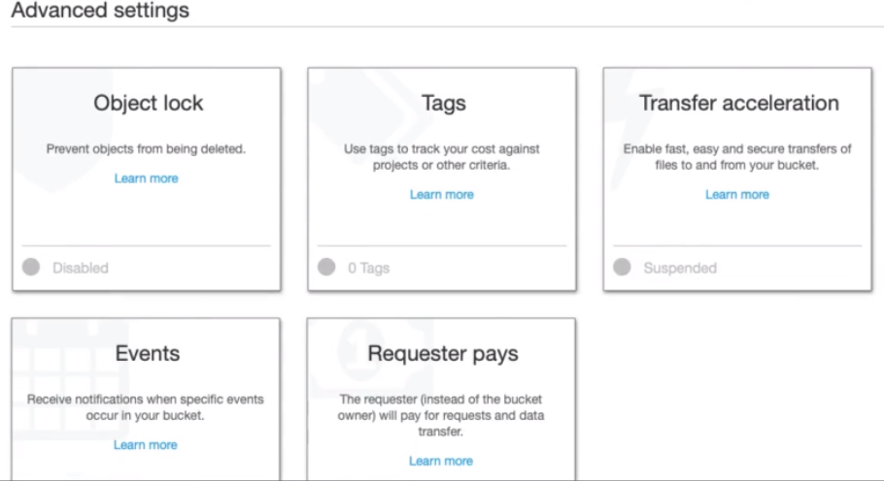

1. **Object Lock:**

It helps to prevent objects from being deleted.

|  |  |
| --- | --- |
|  | Object lock can only be enabled at the time of object creation. So if we click on the Object Lock the we will get the below message in the image:  Amazon S3 currently does not support enabling object lock after bucket has been created and to enable object lock for this bucket contact customer support. |

So to create the object lock let’s create a new object with object lock.

* Go to Amazon S3 bucket > Click on create bucket button.

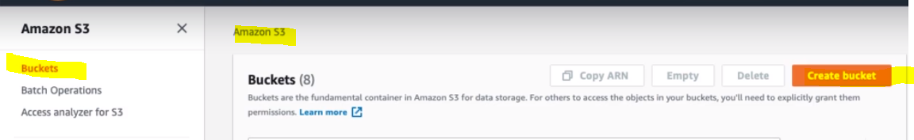

Provide the Name of the bucket and in the

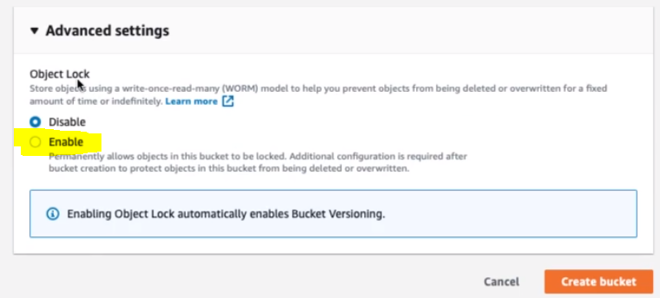

Let’s click on Enable:

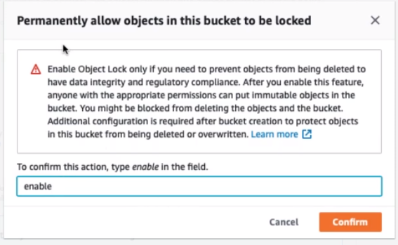

So once we enable object lock on a bucket, we cannot delete object from the bucket.

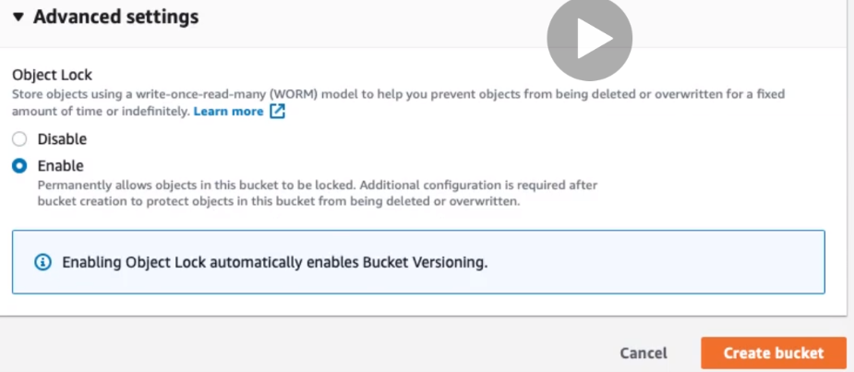

**Once we enable object lock then it automatically enables Bucket Versioning.**

**So this all about the Object lock on the bucket:**

1. **Tags**

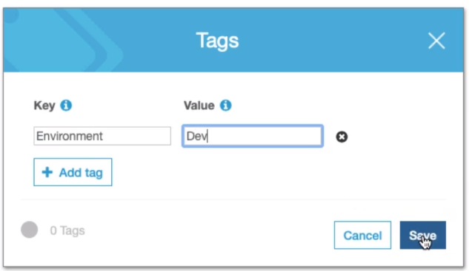

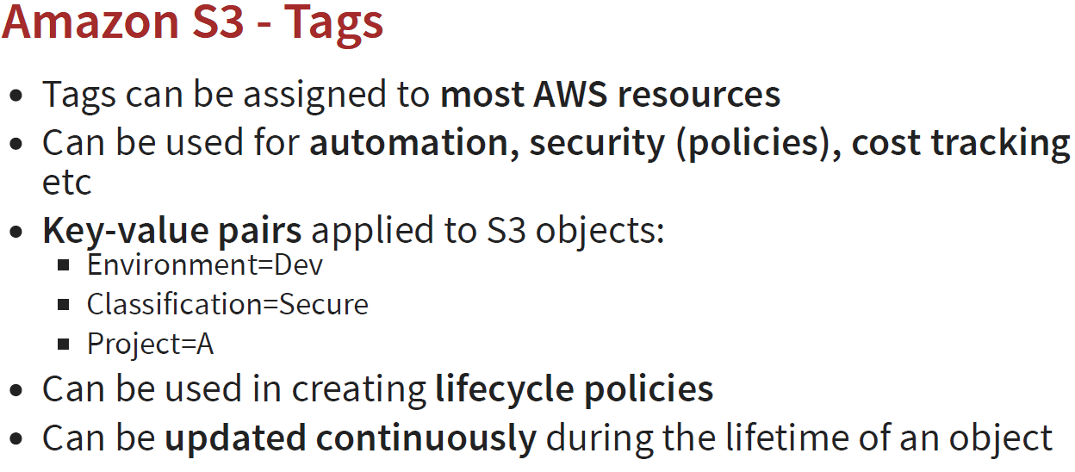

1. **Transfer acceleration**

It enables fast, easy and secure transfers of the file to and from your bucket.

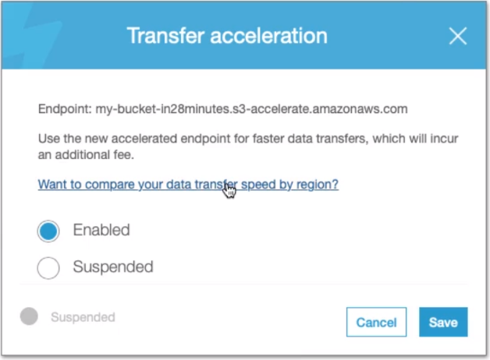

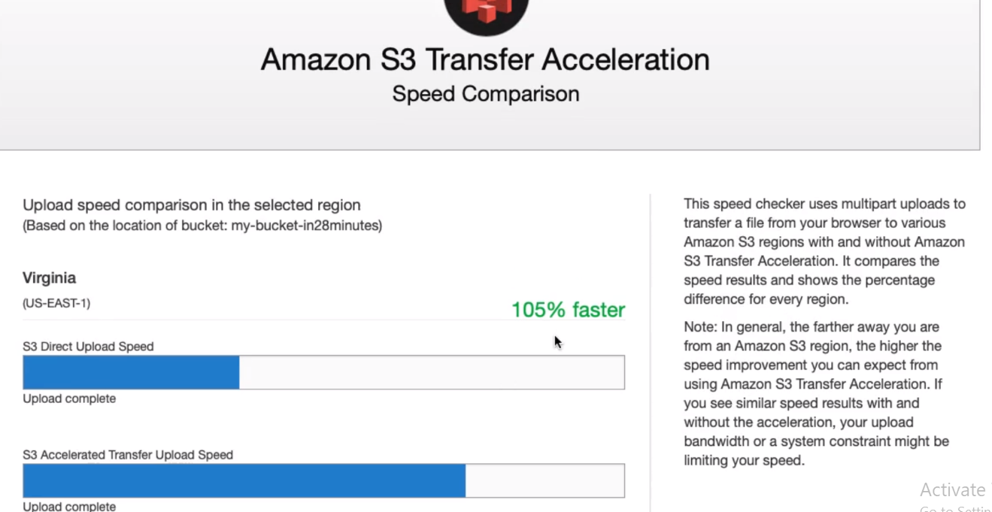

As we know that in AWS we have Region and edge location and it transfer the file from edge to edge instead of Region that is why it makes it faster.

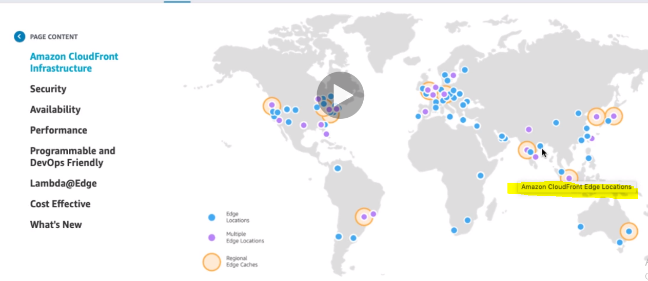

It is not free so enable it very carefully.

1. **Requester Pays**

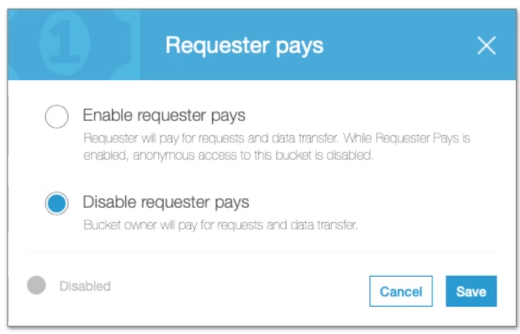

So sometime someone wants to store their files or object in your bucket, so in this case the requester who wants to store their files will have to pay. So Requester will pay for request and data transfer, while request pays is enabled, anonymous access to this bucket is disabled.

Course Update : Requestor Pays

A quick correction on Requestor Pays:

<https://docs.aws.amazon.com/AmazonS3/latest/dev/RequesterPaysBuckets.html>

*In general, bucket owners pay for all Amazon S3 storage and data transfer costs associated with their buckets.*

*A bucket owner, however, can configure a bucket to be a Requester Pays bucket.*

*With Requester Pays buckets*

*- The requester instead of the bucket owner pays the cost of the request and the data download from the bucket*

***The bucket owner always pays the cost of storing data.***

**129. Step 10 - Exploring S3 Event Notifications**

Whenever we want to add object into bucket or whenever we want to delete an object from the bucket or whenever we modify an object in a bucket then in these cases we want send out a notification to lambda function and that we can do using S2 Event Notifications. So-

1. Configure notifications when certain events happen in your bucket

Here we have multiple event sources for event notification from where event can be triggered.

**Event Sources: i.e. Event will be triggered when**

* New object created events
* Object removal events
* Reduced Redundancy Storage (RRS) object lost events
* Replication events

So when an event will be triggered then in this case it can be stored or invoke one of these given list below

**Event Destination:**

* Amazon SNS topic
* Amazon SQS queue
* AWS Lambda function

In short:

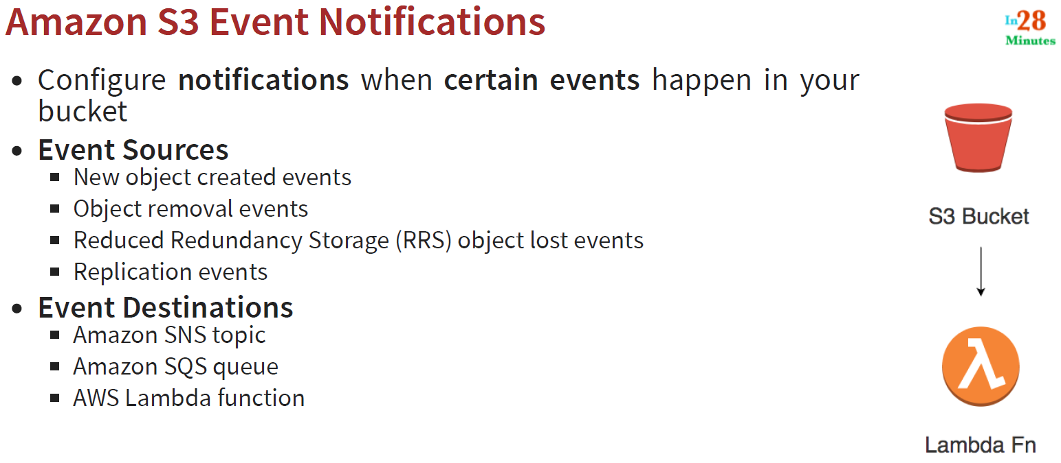

**130. Step 11 - Implementing S3 Event Notifications with AWS Lambda**

In this step let’s trigger lambda function based on notification from S3 buckets.

* Go to the lambda function > Create a new Lambda function > Select Author from scratch
* Provide the lambda function name

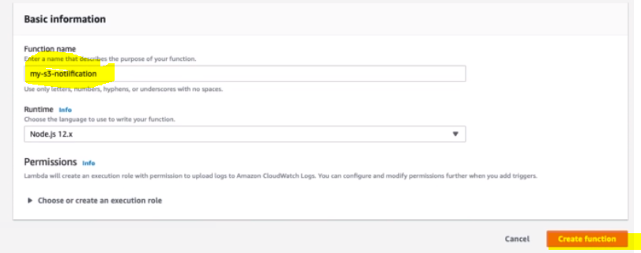

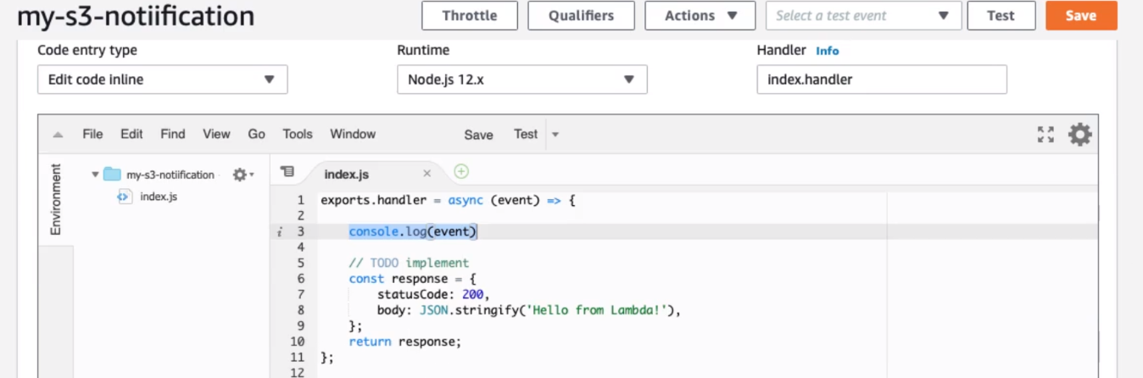

So here we will just add one console log just to check when notification triggers this lambda function.

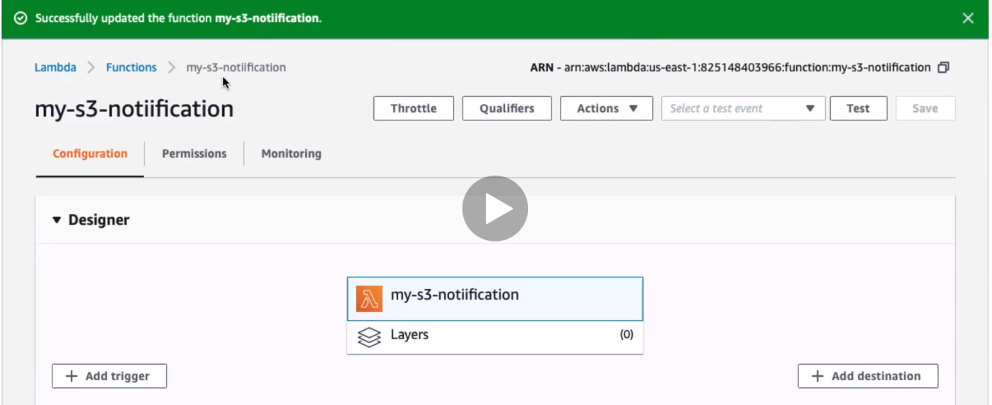

So we have created my-s3-notification lambda function.

Now let’s go to S3 and configure this lambda function for S3 notification.

S3 > Buckets > Go to already created bucket “my-bucket-in28minutes”

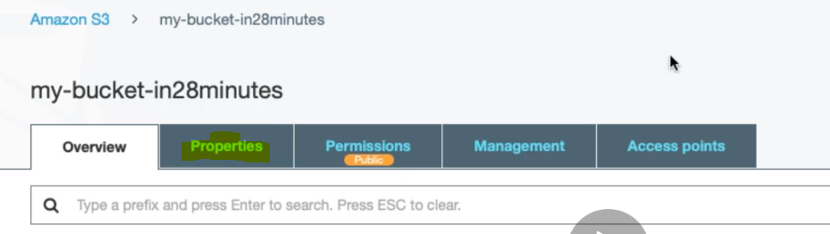

**Go to properties: > Go to Event Tab**

|  |  |
| --- | --- |
|  |  |

Click on + Add notification

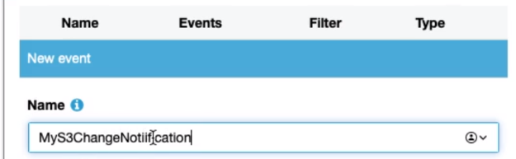

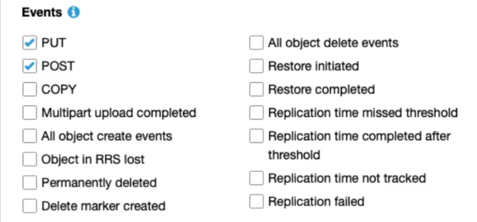

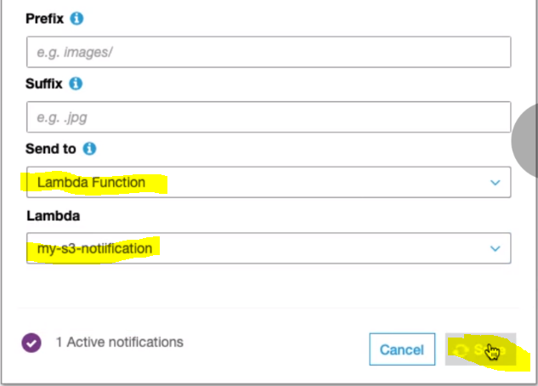

So above we have provided the Notification event Name.

Selected the event Put & Post based on requirements.

Select the Destination- send to [Lambda Function]

Select the created lambda function which needs to be triggered when PUT, POST event occurs.

Click – Save

|  |  |
| --- | --- |
|  | And Events Notification is Active. |

Now let’s start testing just by uploading the file in the bucket:

Let’s go to bucket Overview Tab > Upload the file.

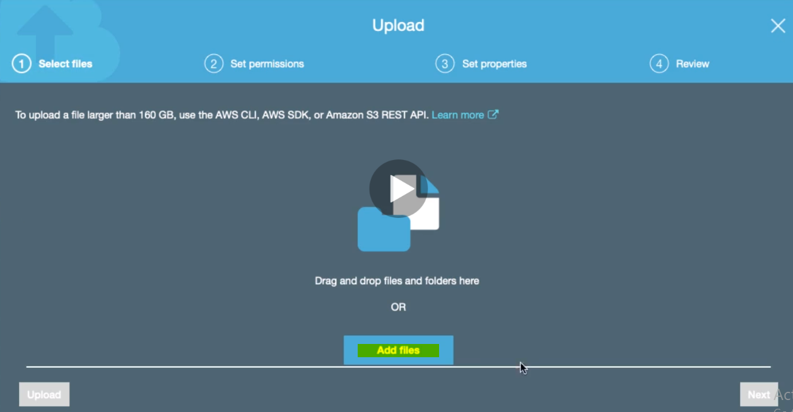

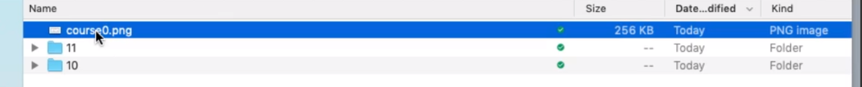

Next > next

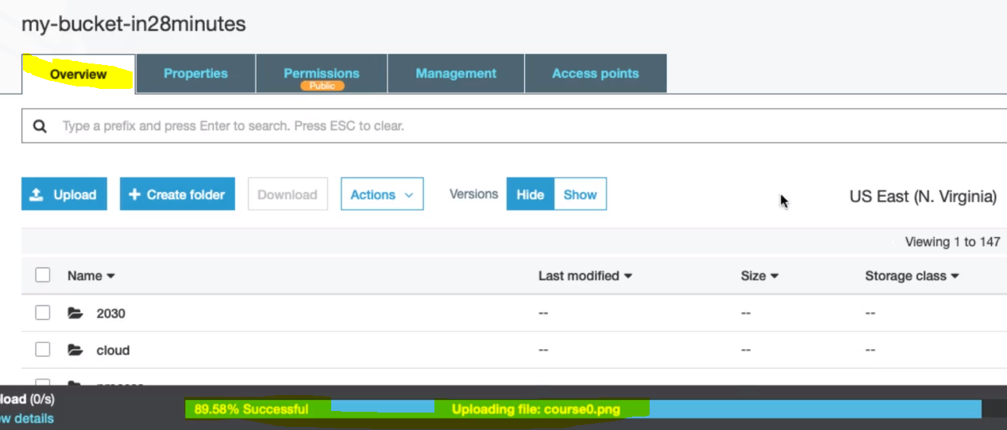

Uploading the file. Once 100% load is completed.

Now let’s go to lambda function log and check whether event is triggered or not.

Lambda > Function > my-s3-notification

Click Monitoring > Click on View logs in CloudWatch

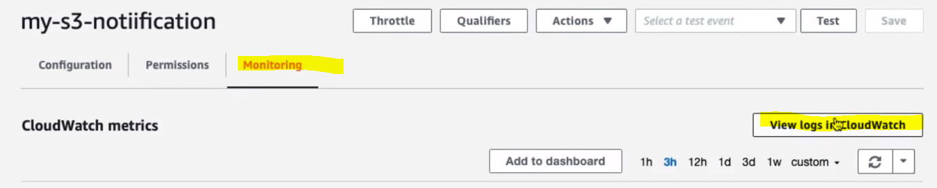

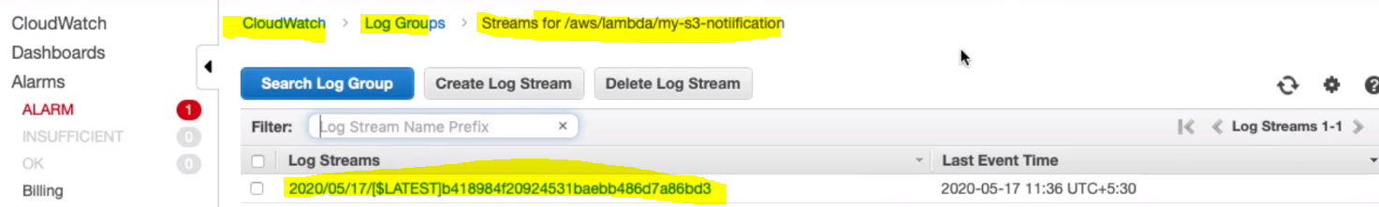

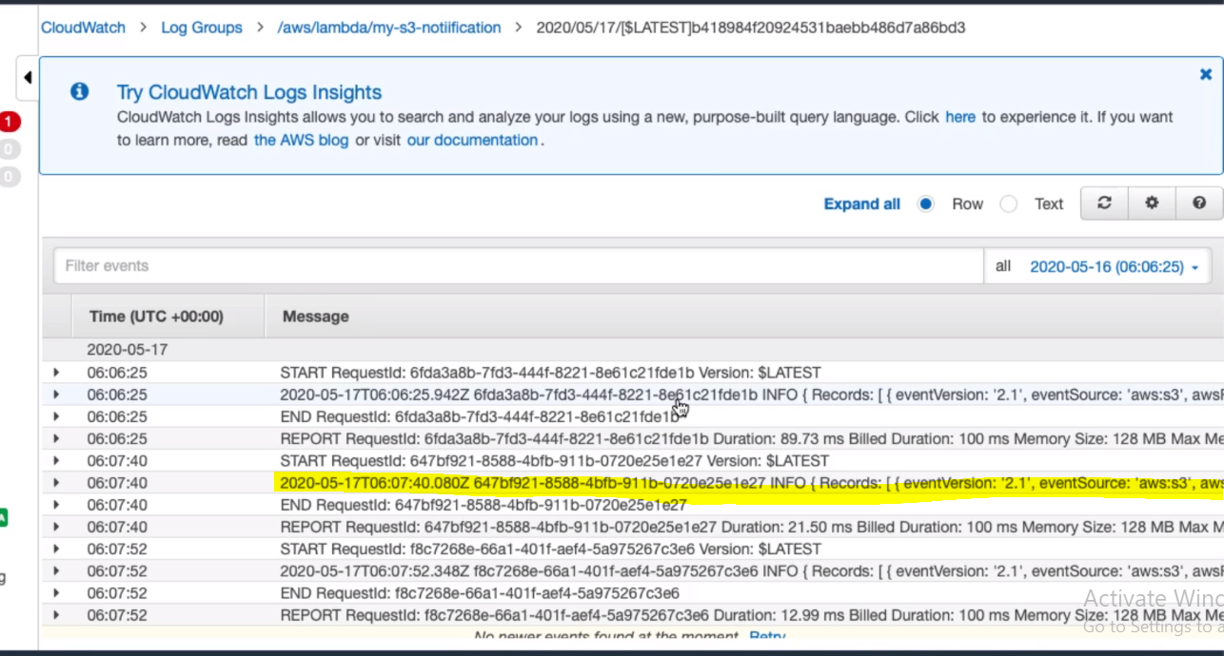

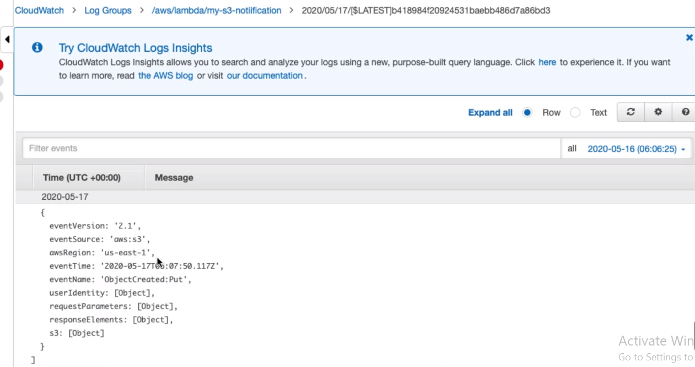

So in this way we have seen that put method is triggered and lambda function got invoked and we can see the output in the log.

So we can use this event feature when anyone want to upload image and want the same image to be shown as a thumbnail using lambda function. So Event is very important feature in S3.

**131. Step 12 - Playing with S3 Prefixes**

In the previous step when we are configuring event with Lambda function then we have got the option to put prefix and suffix .

* It Allows you to search for keys starting with a certain prefix
* So let’s say if we are Searching with prefix 2030/10 then it will return
* 2030/10/course1.png & 2030/10/course2.png
* We can alos use as a query parameter : URL - <http://s3.amazonaws.com/my-bucket-ranga?prefix=2030/10/>
* Above URL would work only when public access is allowed
* Prefix is also Supported by REST API, AWS SDK, AWS CLI and AWS Management Console
* Prefix can also be used in IAM and Bucket Policies to restrict access to specific files or group of files

So in short:

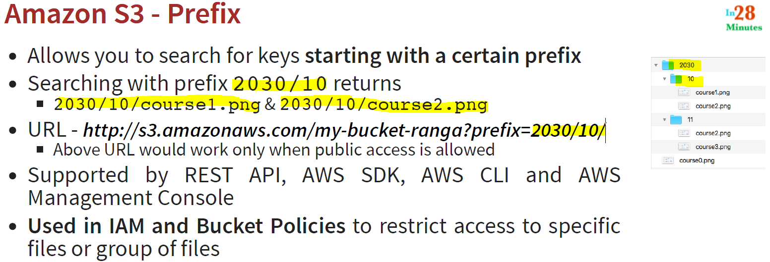

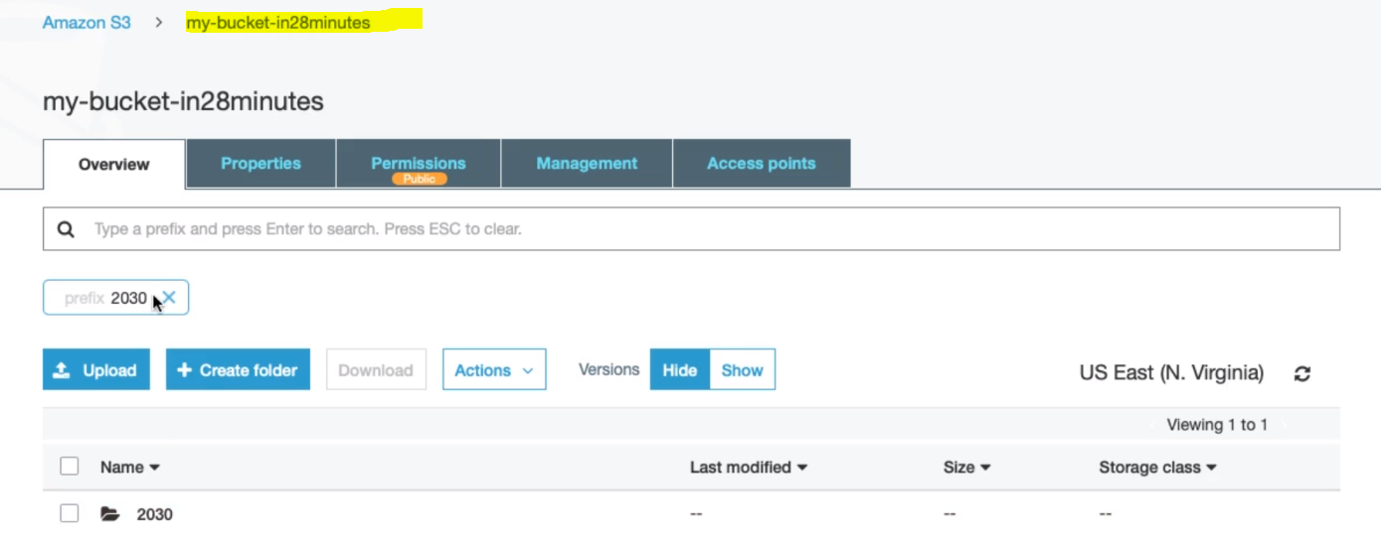

We are inside bucket my-bucket-in28minutes and we are searching 2030 and in result it is displaying the same.

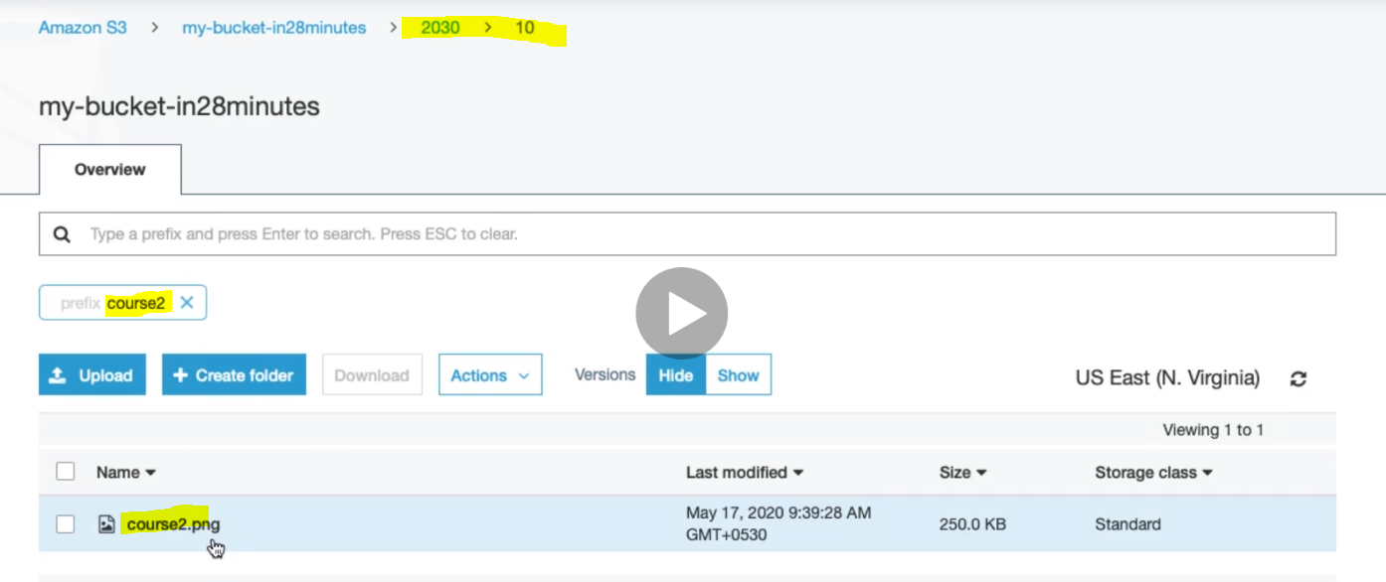

Here we are inside folder 10 and trying to search cource2 and in result we are getting correct result.

Now let’s try to get the same result using URL : <http://s3.amazonaws.com/my-bucket-in28minutes?prefix=2030/10/>

Now if we put and hit this URL in the browser then let’s see what happens?

[http://s3.amazonaws.com/my-bucket- in28minutes?prefix=2030/10/](http://s3.amazonaws.com/my-bucket-ranga?prefix=2030/10/)

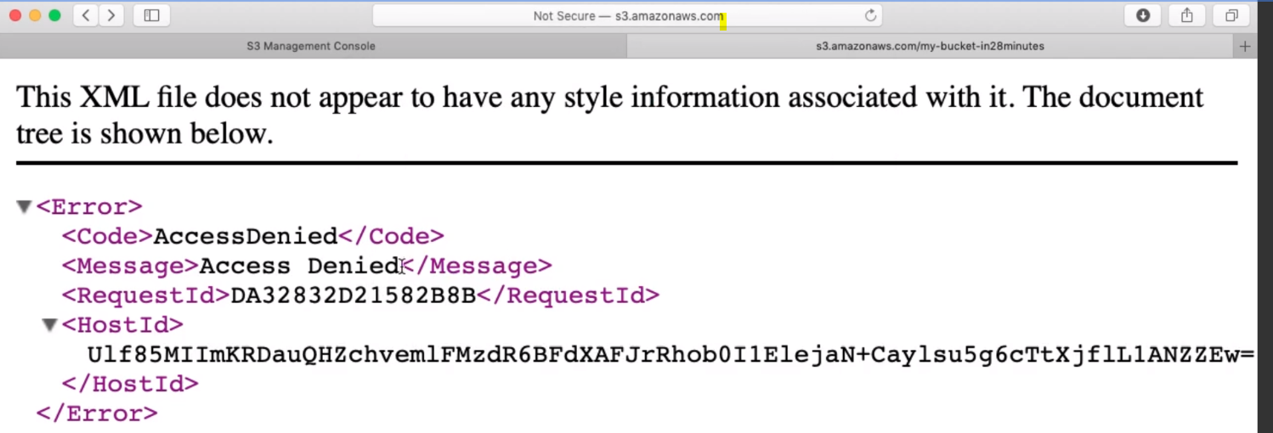

**So are getting Access Denied**

**So let’s provide the permission from the permission tab of the bucket:**

**Amazon S3 > bucket name (my-bucket-in28minutes) > Permission Tab > Go to Access Control List:**

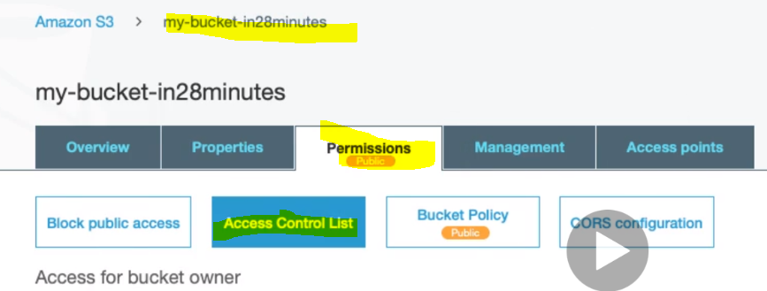

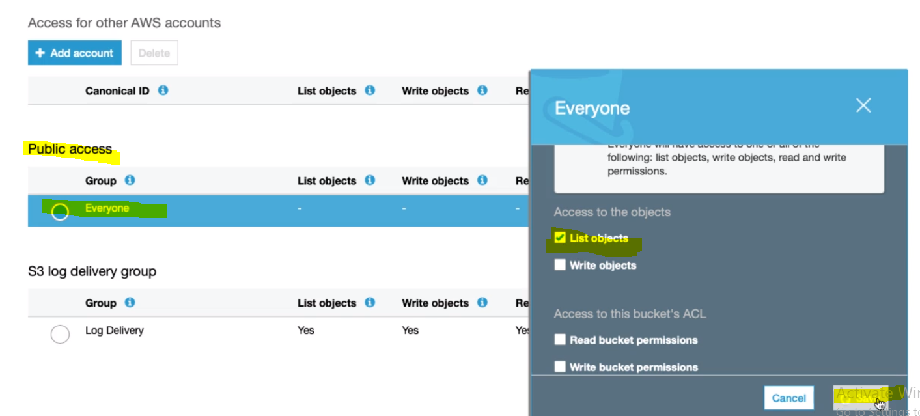

**Now if try to execute the same URL then we will get all the information related to bucket:**

**http://s3.amazonaws.com/my-bucket- in28minutes**

Here it will show the complete object

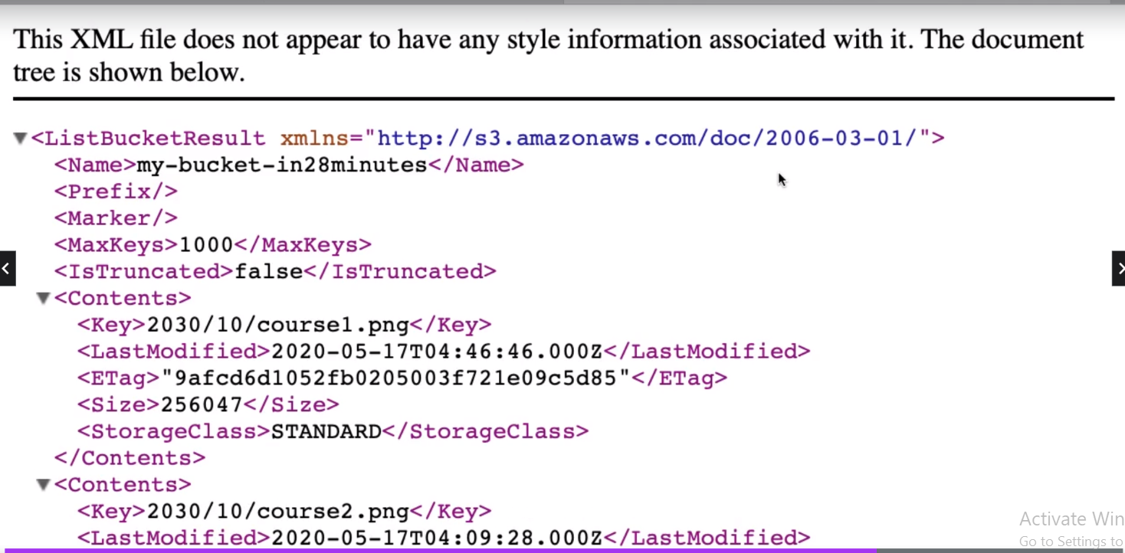

**So we are getting all the information**

**Now if we search with the prefix then it will show the files related with its prefix>**

<http://s3.amazonaws.com/my-bucket-in28minutes?prefix=2030/10/>

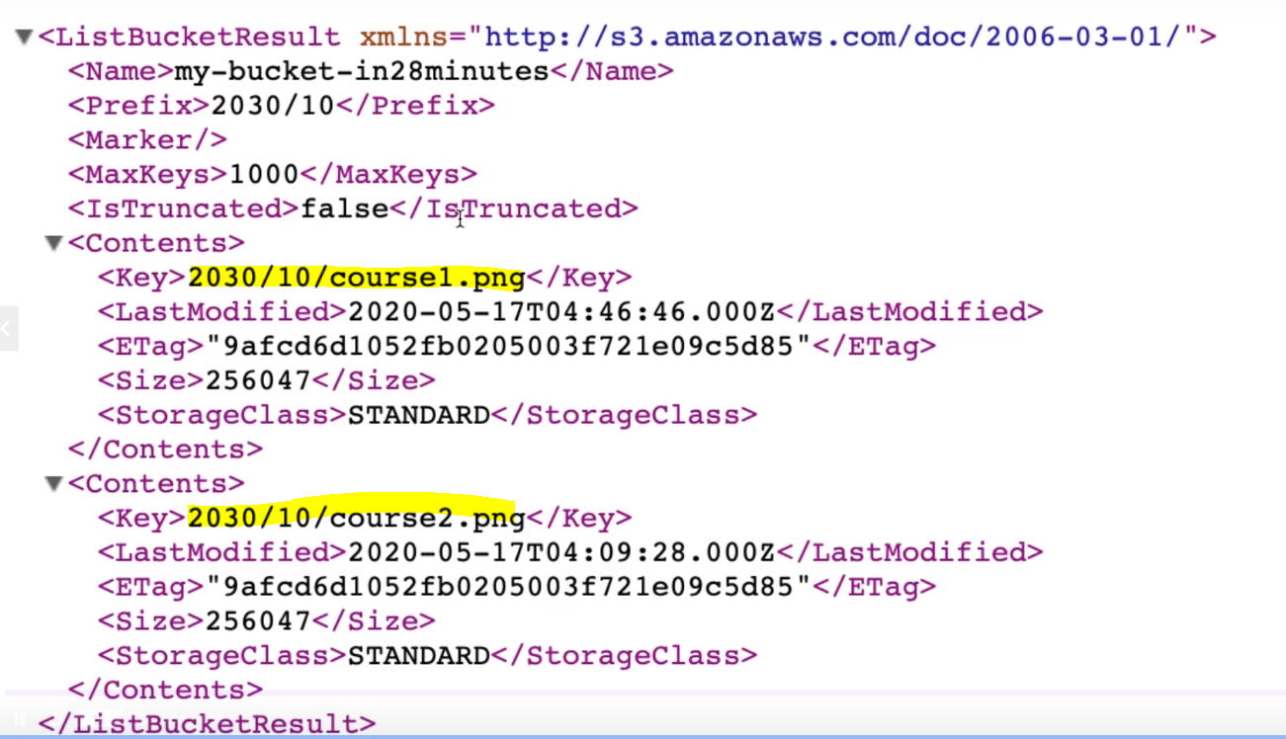

**132. Step 13 - Exploring Bucket and Object ACLs in S3**

In this step we will talk bit more about permission tab of S3 bucket:

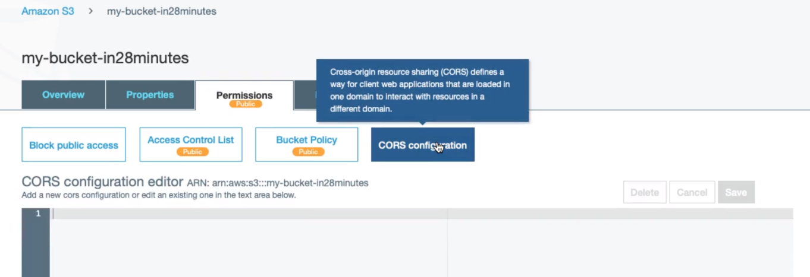



So far we have discussed about

* **Block Public Access:** It’s a higher level access, so to allow the public access using Access Control List or Bucket Policy, the Block Public Access should be turned off. So if we turned it on then what the access we have given earlier will stop working i.e. it will override all the access that we have configured.
* **Access Control List**
* **Bucket Policy: It is the policy at the bucket level, so if we are configuring everybody should be able to read**
* **CORS**: And now let’s talk about CORS configuration: CORS stands for ‘Cross-origin resource sharing, which defines a way for client web applications that are loaded in one domain to interact with resources in a different domain.

Typically when we talk about static content, it might be possible to reuse in other website in this case we will use CROS.

If we scroll down then we will get one link ‘Documentation’

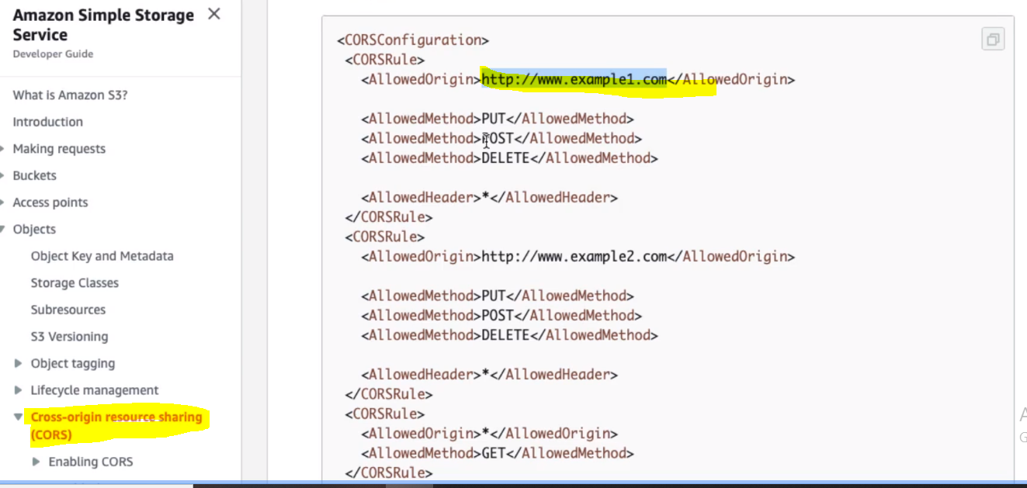

So here we can see the allowed origin and allowed method that we can configure based on our requirements.

**Block Public Access:**

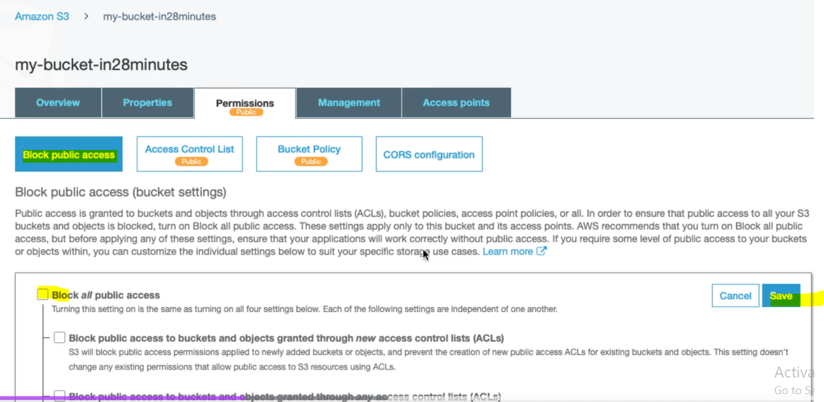

**Bucket Policy:**

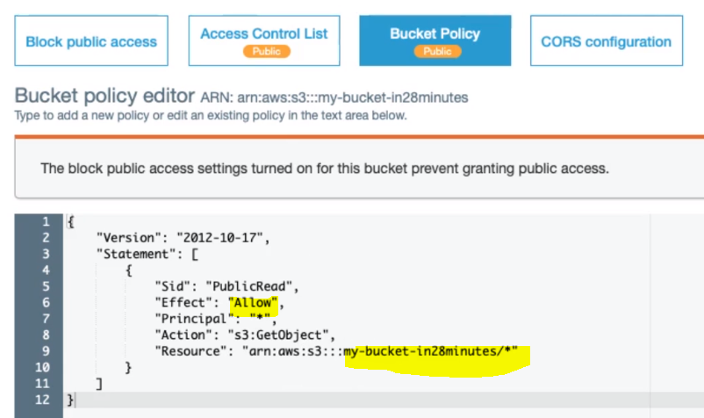

* **Access Control List(ACLs)**

Object level access we can provide from here:

In-short:

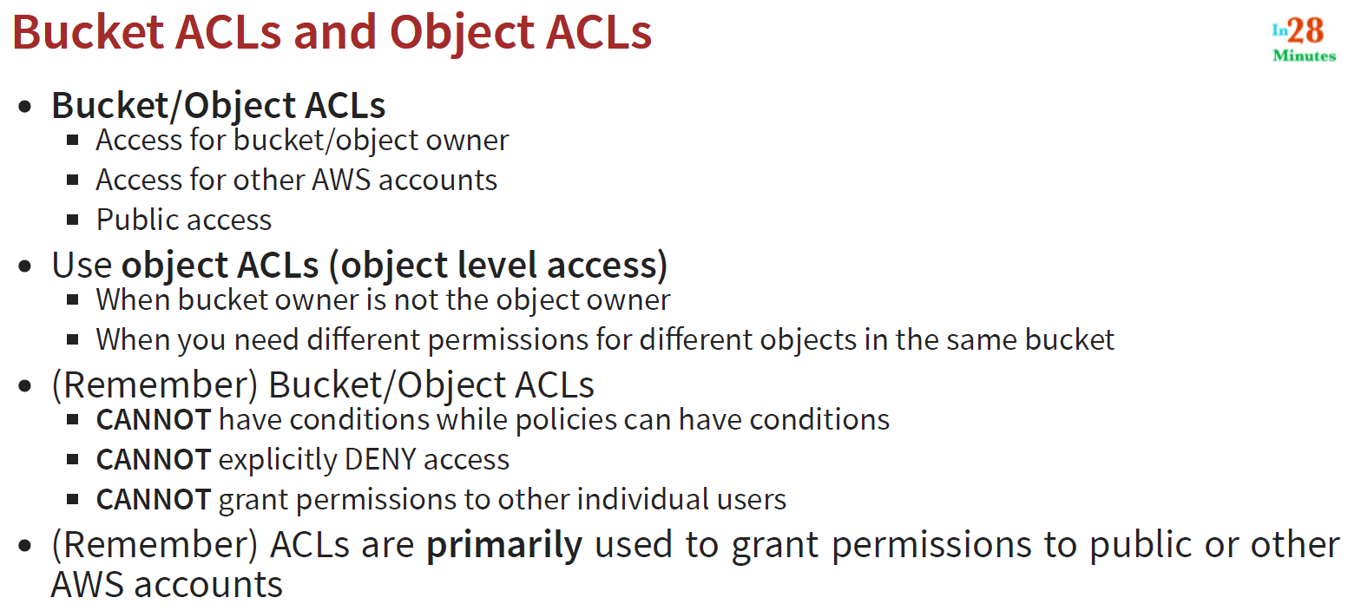

**133. Step 14 - Getting Started with S3 Storage Classes**

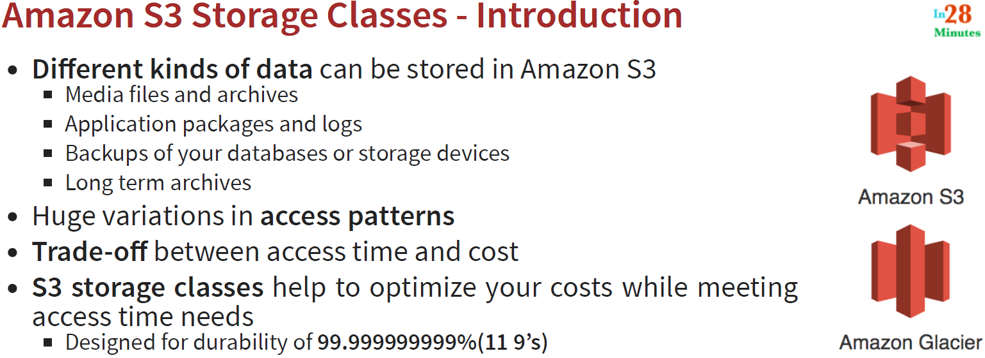

So as per the above points we can brief that there we have different kind of data that can be stored in Amazon S3. Some kind of data access may be required immediately like (Application packages and logs, Database Backups or storage device) and some kind of data access may require after an hour or week. So based on data there we have huge variation of access patterns and based on theses access pattern we can trade-off between access time and cost.

S3 storage class is designed for durability till 11 9’s.

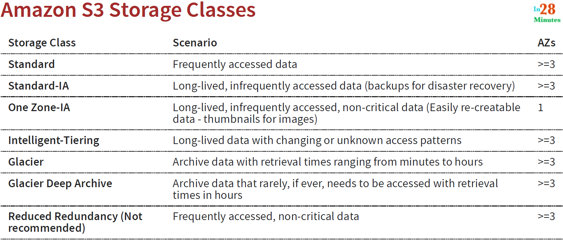

So we can select the storage class based on the scenario and then accordingly we can store the data and its replicas in 1 or >=3 Availability Zones.

**134. Step 15 - Comparing S3 Storage Classes**

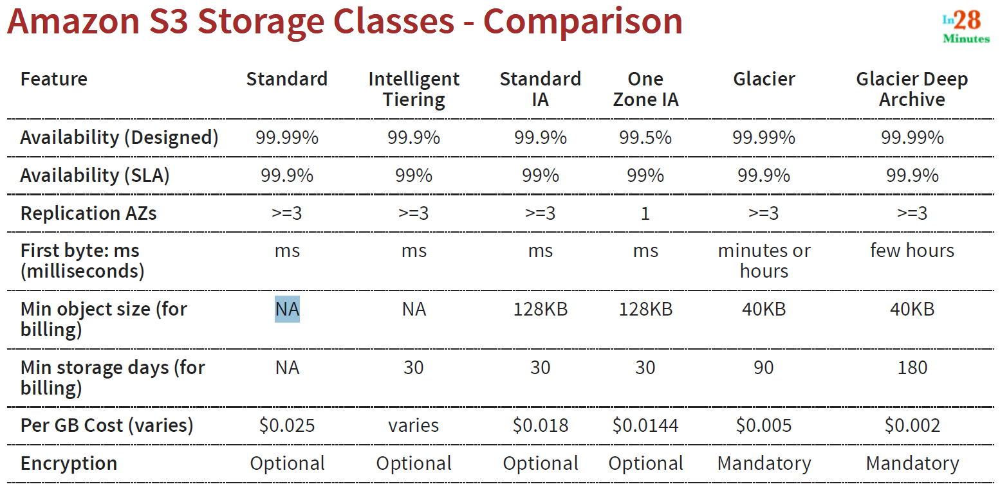

* So if we want immediate access and very high availability then we need to go for standard S3
* If we want archive then we need to go for Glacier or Glacier Deep Archive and it provides more benefits in terms of cost compare to others S3 and one most important thing to remember is encryption is mandatory is Glacier and Glacier Deep Archive.

**135. Step 16 - Exploring S3 Lifecycle Configuration**

In the last few steps we have talked about S3 storage classes, in this steps let’s play with some of the objects and try and shift between them storage classes.

Let’s go to AWS S3 🡺 my-bucket-in28minutes🡺folder 2030

Let’s pick up one of the files from folder 2030:

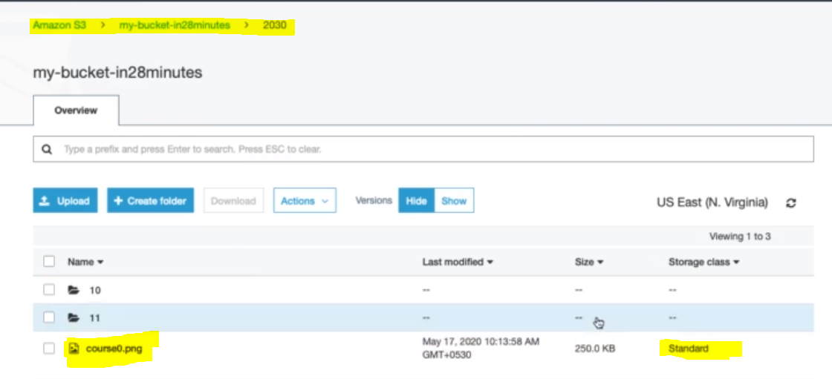

Here we can see that the storage class for this png file is – standard.

|  |  |
| --- | --- |
|  |  |

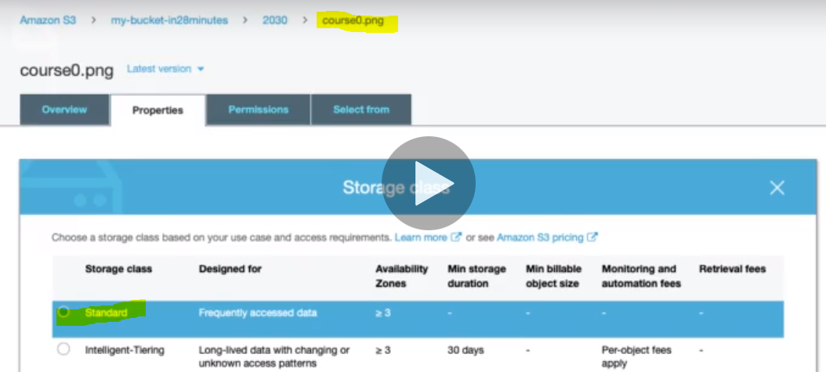

Now let’s modify it to some other storage class. Let’s go to Properties tab🡺 Go to storage class

Now let’s select another storage class other than standard:

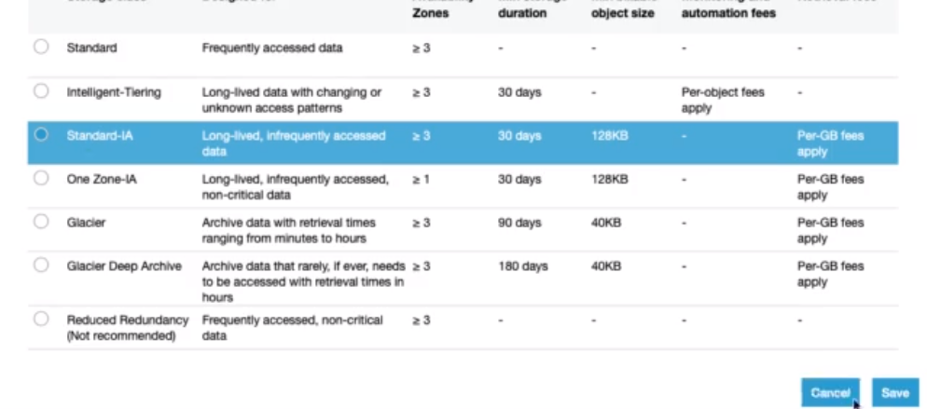

So we can select any of these given:

Note: if we move out this object to Glacier or Glarcier Deep classes then we will not able access after words. That is why we will select the storage class either Intelligent-tiring or Standared-IA or One Zone-IA. So let’s choose Standard-IA and save.

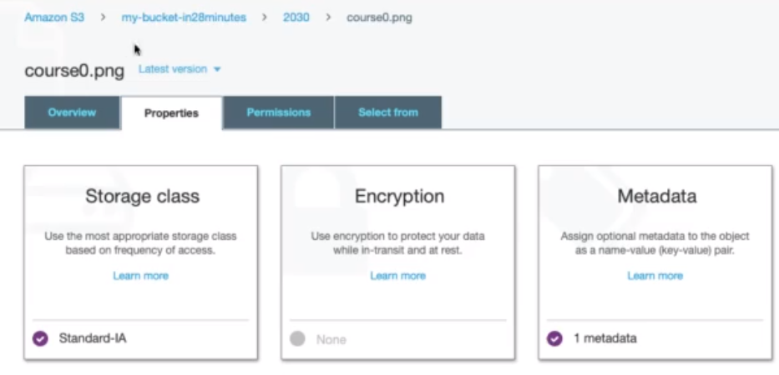

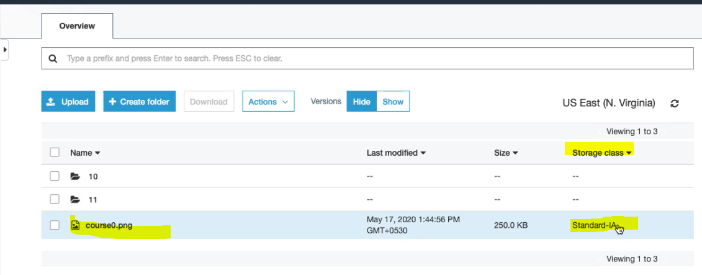

Now if go back and try to check then it has been shifted to Standard-IA from Standard storage class.

**Note**: We can select the storage class while uploading the object:

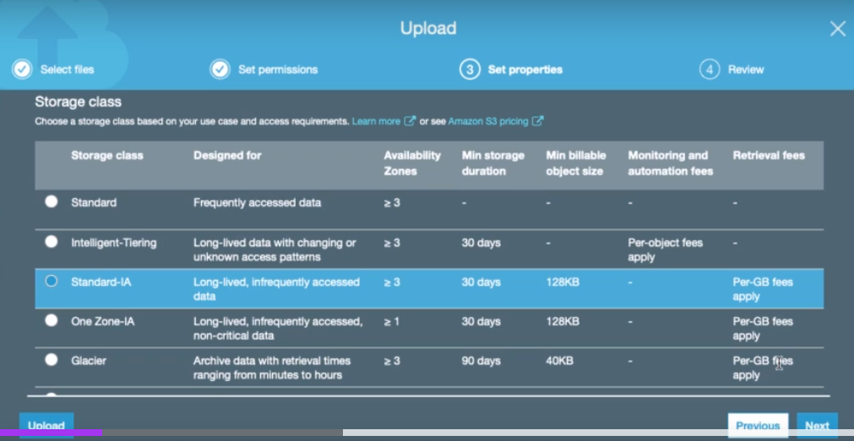

Note: as we have verity of S3 storage classes and we saw that we can switch the object from one class to another class. Let’s say if we have 1000 of the object to be moved to another class then it would be very time consuming and hectic and that is why in this case S3 life cycle comes into picture to make it easy. S3 lifecycle helps in automating this switching activity.

To configure S3 life cycle 🡺 go to Management Tab 🡺 click on Lifecycle tab as we can see in the below image.

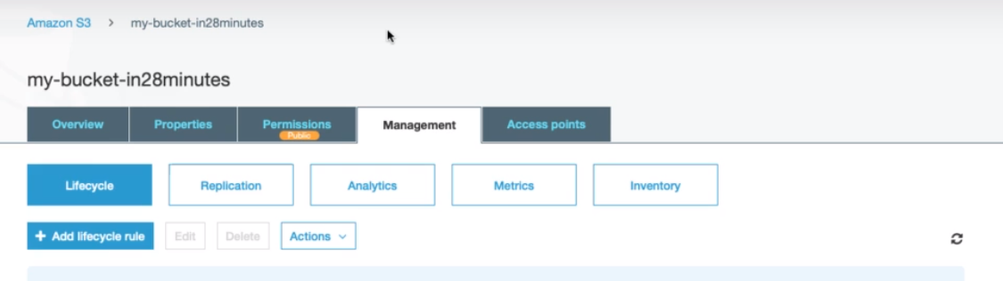

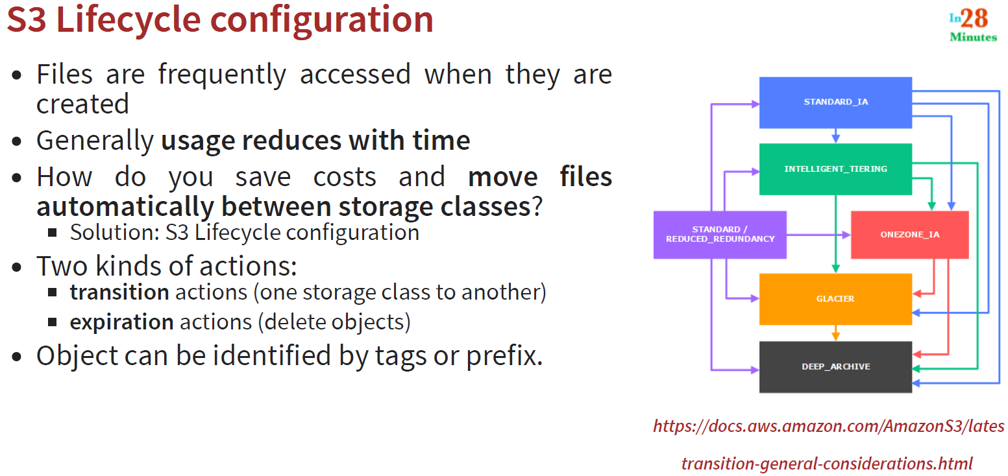

So as here we can see that when the Files are created then its uses gets reduces with time and in this case to move un-important files file to from one storage class to another storage class and this we can achieve automatically using S3 lifecycle configuration.

We can apply two kinds of actions.

1. Transition or movement from one storage class to another
2. Apply the expiration action i.e. after a certain period let’s delete these objects, we can apply these actions on an object by using tags or prefix

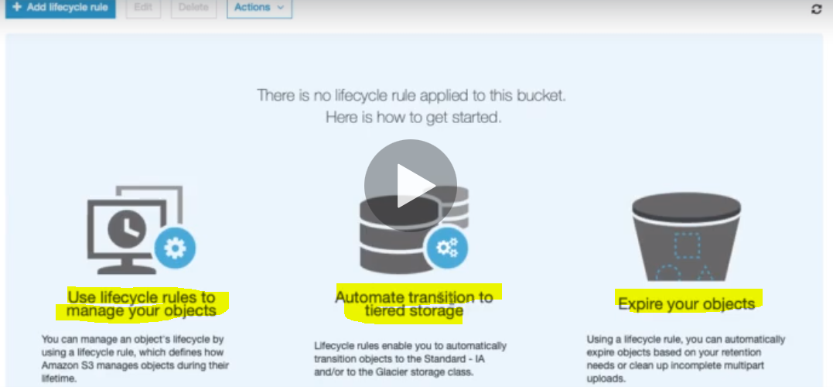

Click + Add lifecycle rule:

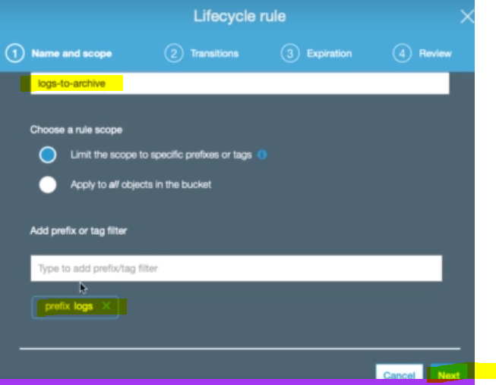

Here we are creating rule name files start with logs to be archive

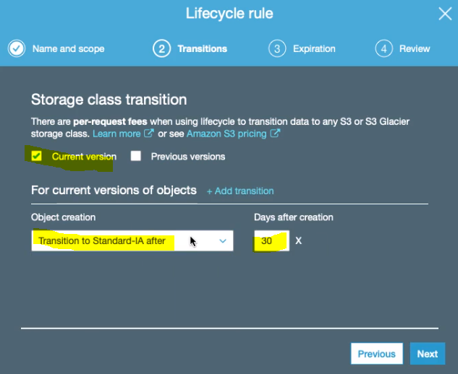

We are moving the entire current version to Standard-IA after 30 days

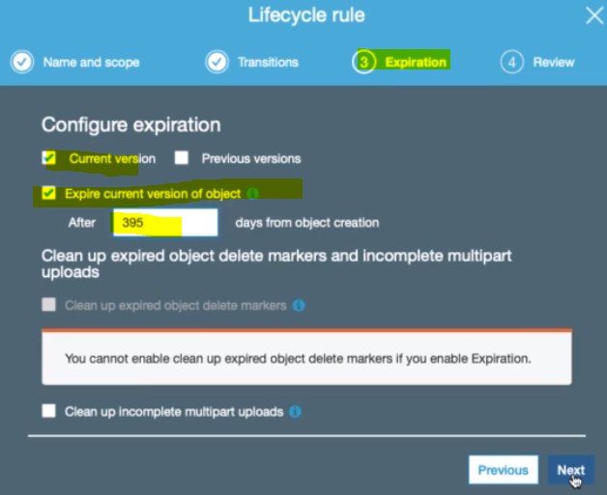

Now in this step we are applying expiring days 395- i.e. logs files will be expired after 395 days

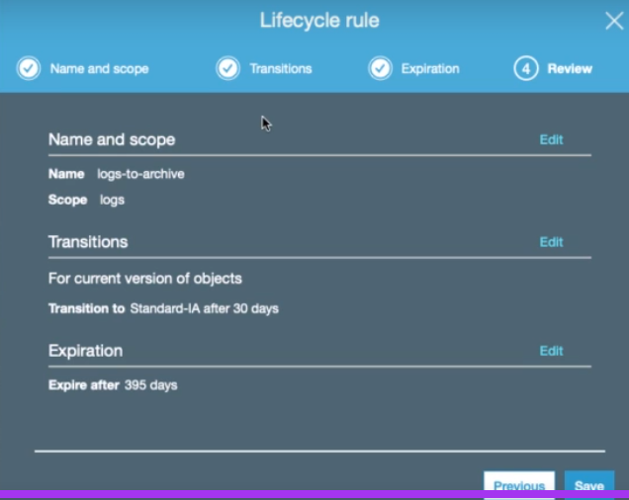

Finally save

Note: Since S3 life cycle will cost you so, do not save if you using this account just for learning.

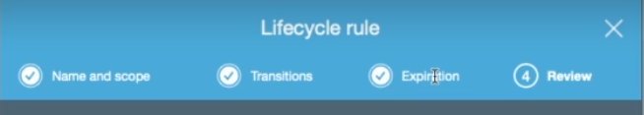

So basically we have 4 phase of S3 life cycle

1. Name and scope
2. Transitions
3. Expiration
4. Review

**WARNING! BILLING ALERT! Do NOT Enable CROSS Region Replication**

S3 Cross-Region Replication is not free.

In the next step **DO NOT** **SETUP**cross-region replication if you want to remain in the free tier.

I got a bill of $5.11 for the replication I set up in the next step!

**137. Step 17 - Exploring S3 Cross Region and Same Region Replication**

1. Here let’s discuss about bucket replication in the S3.
2. Replicate objects between buckets in same or different regions
3. It Could be replicate between cross account( e.g. from dev account to test account or prod account)
4. It Can be configured at bucket level, a shared prefix level, or an object level using S3 object tags
5. Let’s say if we one source bucket and another one is destination bucket then we then Access to destination bucket is provided using IAM Policy
6. Versioning should be enabled on BOTH source and destination bucket
7. ONLY new objects are replicated (Explicitly copy existing objects), let’s say we have 10 objects in the bucket and we have turned on the replication then these 10 object cannot be replicated to another s3 bucket, but we can explicitly copy these existing objects to other bucket
8. (Advantage): Replication Reduces latency and helps you meet regulations e.g. (USECASE) Object replication between dev & test environments

**Configuring S3 Replication:**

Go to “Amazon S3”🡺 my-bucket-in28minutes 🡺 Go to management Tab of the bucket 🡺 Go to Replication

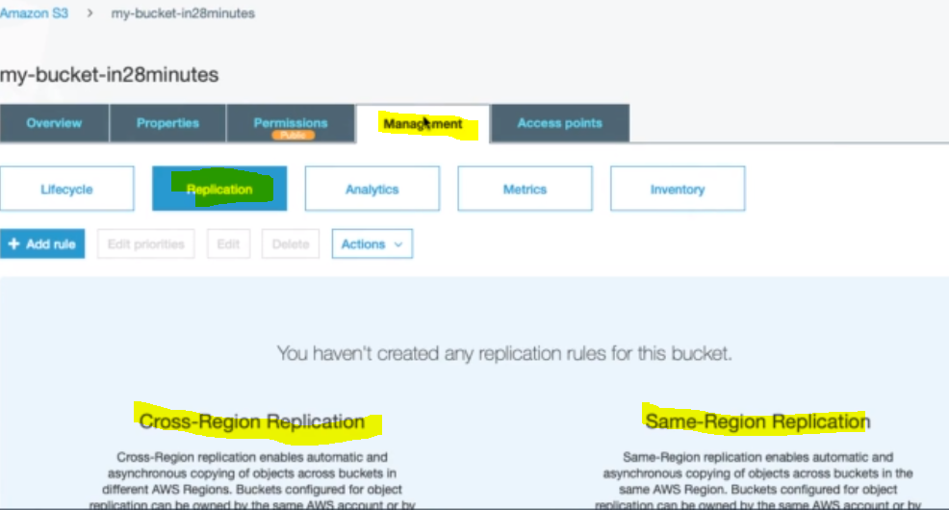



Click on + Add rule button:

1. **Set Source**

|  |  |
| --- | --- |
|  |  |

First enable the versioning choose replication type and criteria

|  |  |
| --- | --- |
| Choose the encryption type- Click next |  |

1. **Set the Destination:** Here we can change the storage class for the replicated objects as well as we can change the object ownership and we can set its replication time.

|  |  |
| --- | --- |
| Here we can choose the destination bucket either in the same account or in another account: | Configure the role |
|  |  |

Click on Save

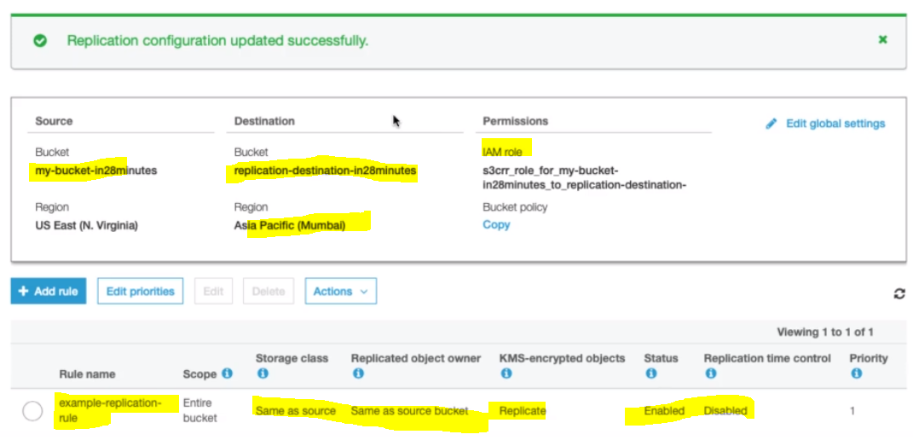

Now let’s go back in the S3 bucket and there we would see new bucke:

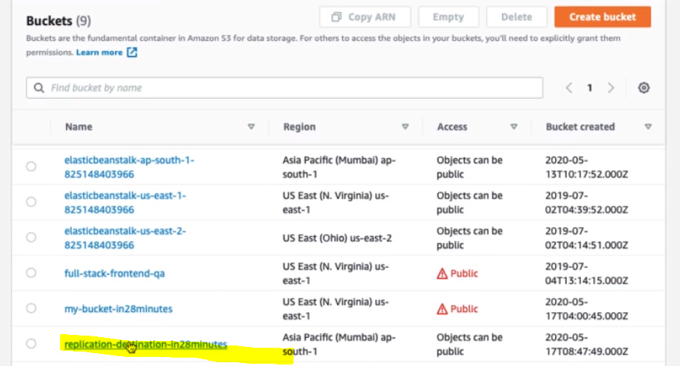

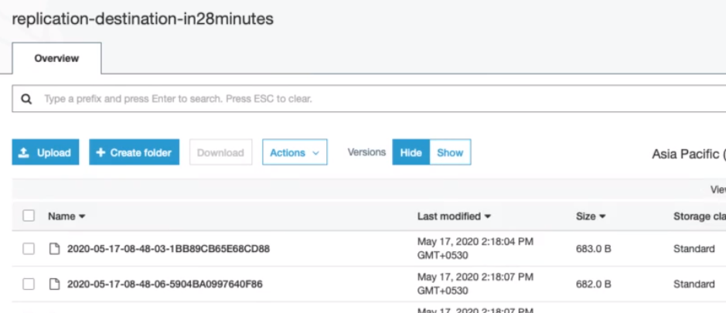

So in this way we can replicate s3 bucket:

**139. Step 19 - Understanding S3 Consistency Model - Eventual Consistency**

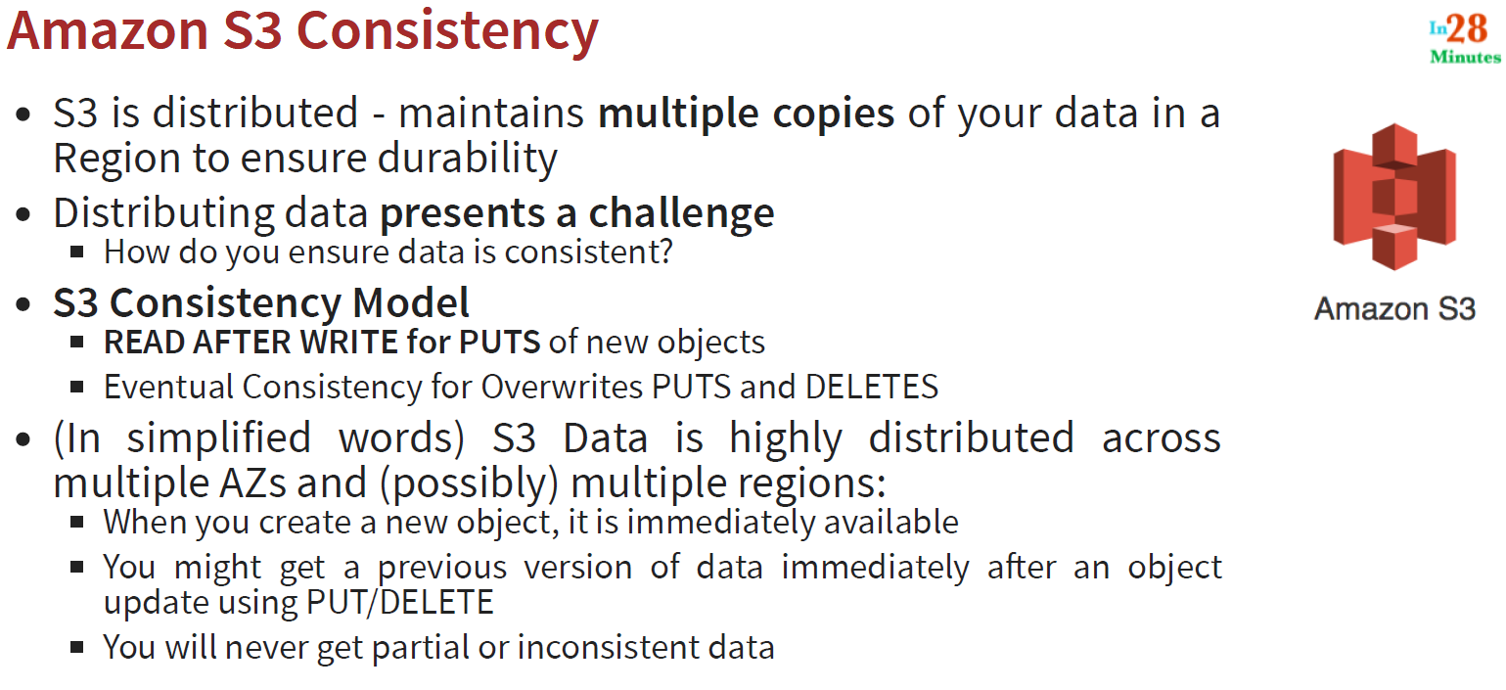

**140. Step 20 - Exploring S3 Presigned URLs**

* Pre-signed URLs is used to Grant time-limited permission (few hours to 7 days) to download objects
* It Avoid web site scraping and unintended access. So if we make everything public then anyone can access it. How do you ensure that the content you put in S3 made available?

Ans: Using pre-signed URLs. To create S3 pre-signed URLs:

**Specify**:

* Your security credentials
* Bucket name
* Object key
* HTTP method and
* Expiration date and time
* Created using AWS SDK API

Creating URL in Java code: Example

* **GeneratePresignedUrlRequest(bucketName, objectKey).withMethod(HttpMethod.GET).withExpiration(expiration);**

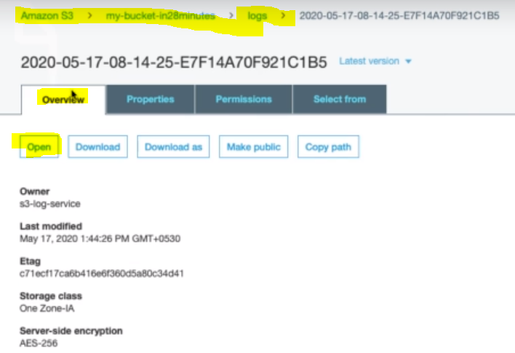

**Goto Overview🡺 click on Open 🡺 it will give the pre-signed URL as given below.**

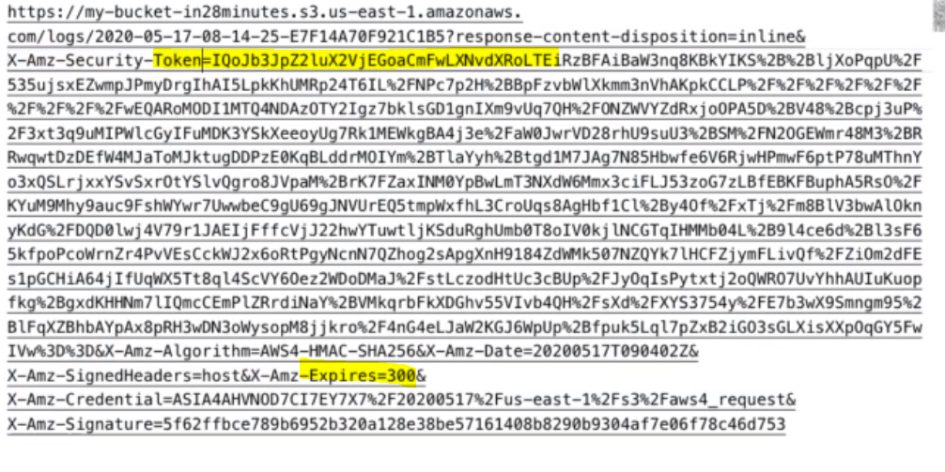

**So here we can see that in every request a token is being sent and we can see that it has expiring time=300s. If any want to access directly with this URL then he cannot access s3 bucket object.**

**141. Step 21 - Basics of Amazon S3 Access Points**

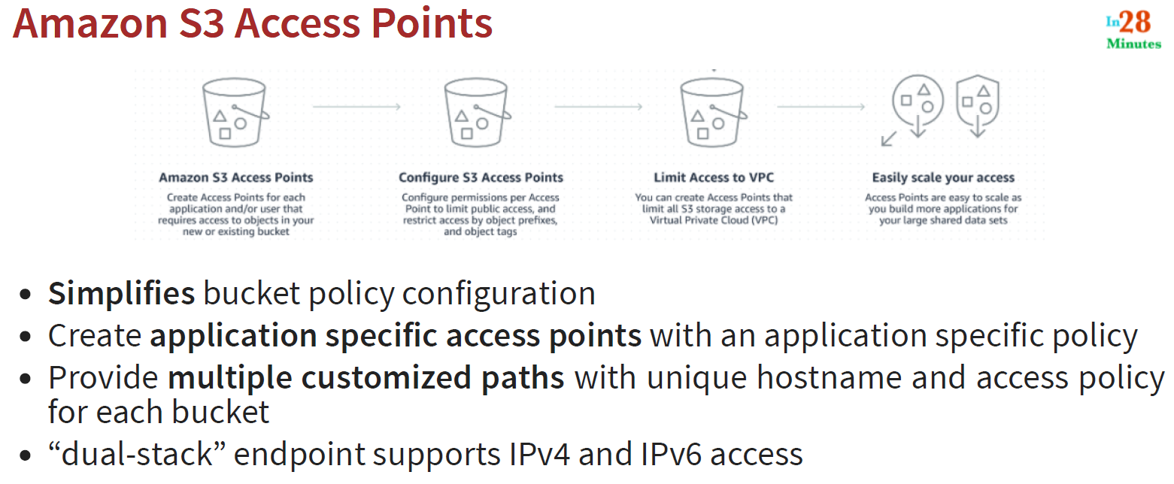

**142. Step 21 - Quick Review of Amazon S3 Security Scenarios**

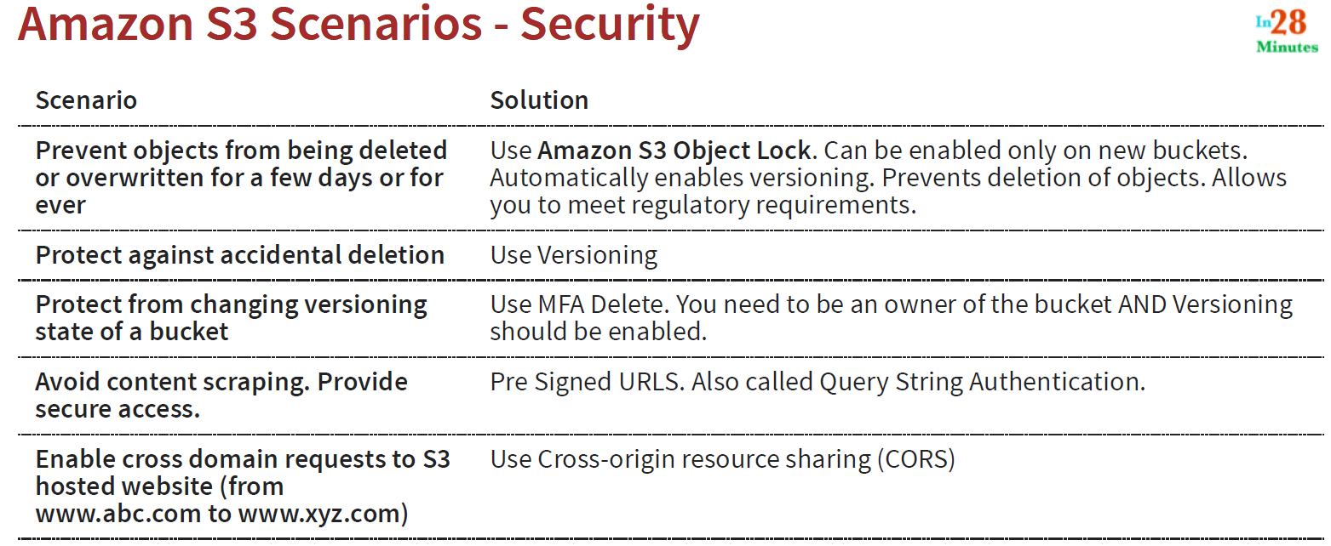

**143. Step 22 - Exploring Different Cost Factors with Amazon S3**

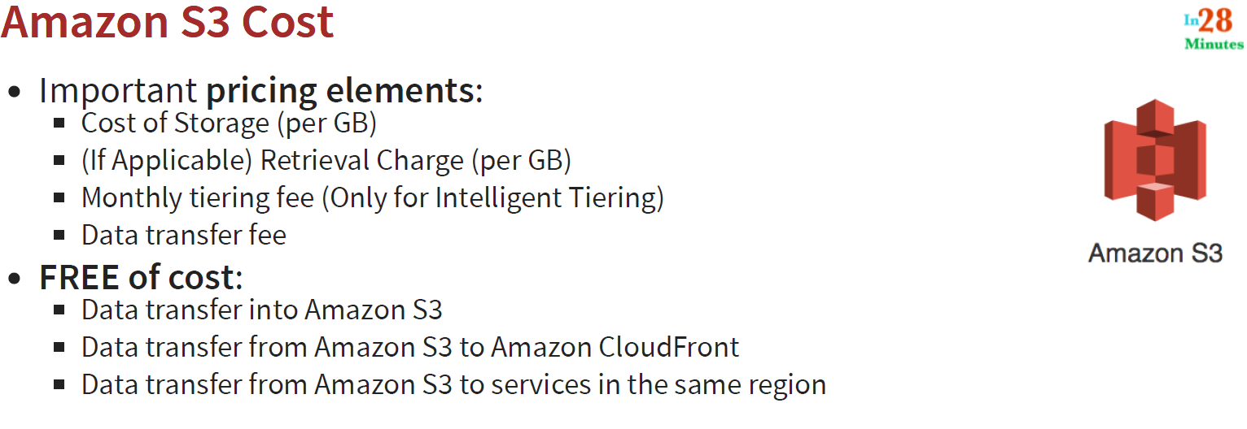

**144. Step 23 - Quick Review of Amazon S3 Cost Scenarios**

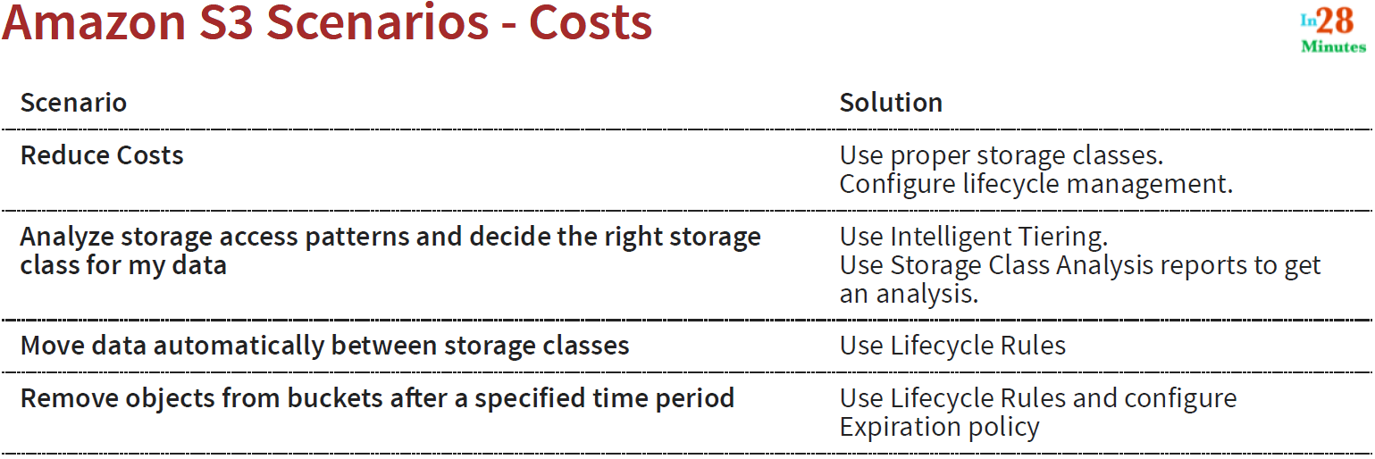

**145. Step 24 - Quick Review of Amazon S3 Performance Scenarios**

Here we will see some of steps to improve Amazon S3 Performance:

1. As we know Amazon S3 is server less, and we don’t need to worry about its deployment stuffs. Just create the bucket and use it for infinite state, so just keep adding data and do not worry about its storage location because is durable and stable
2. Amazon S3 is recommended for large objects
3. Amazon S3 supports up-to

* 3,500 requests per second to add data
* 5,500 requests per second to retrieve data
* Zero additional cost
* With each S3 prefix

1. Transfer acceleration

* Enable fast, easy and secure transfers of files to and from your bucket

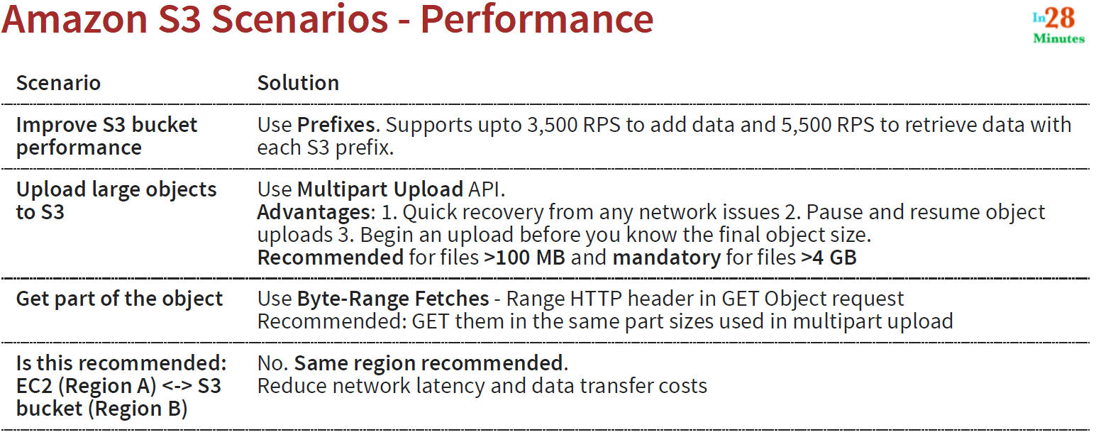

**146. Step 25 - Exploring S3 Features using Scenarios 89dB v2**

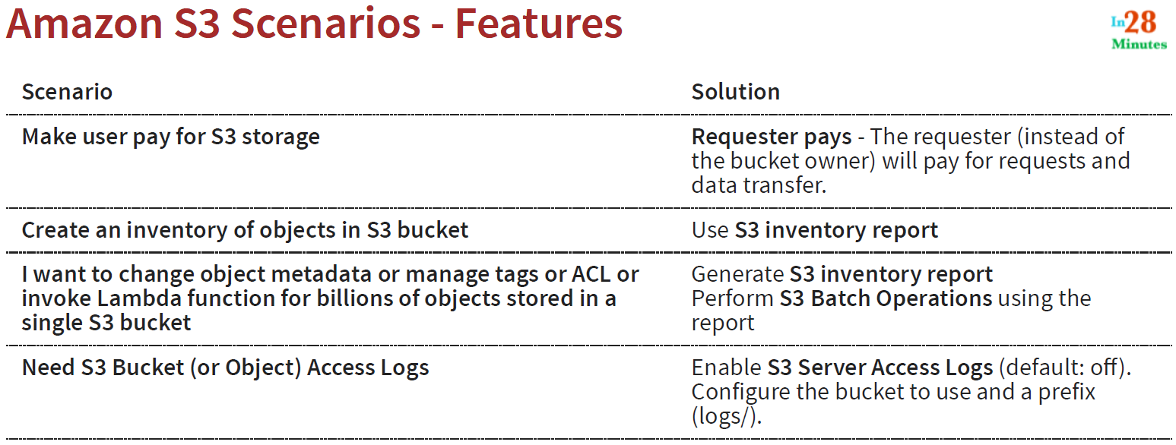

**147. Step 26 - Getting Started with S3 Glacier - S3 vs S3 Glacier**

1. In addition to existing as a S3 Storage Class, S3 Glacier is a seperate
2. AWS Service on it own!
3. Extremely low cost storage for archives and long-term backups:

For example Old media content

For example Archives to meet regulatory requirements (old patient records etc)

For example As a replacement for magnetic tapes (media records)

1. Provides High durability (11 9s - 99.999999999%)
2. Provides High scalability (unlimited storage)
3. Provides High security (**encrypted** at rest and in transfer)
4. Cannot upload objects to Glacier using Management Console

Use REST API, AWS CLI, AWS SDK to upload objects to Glacier

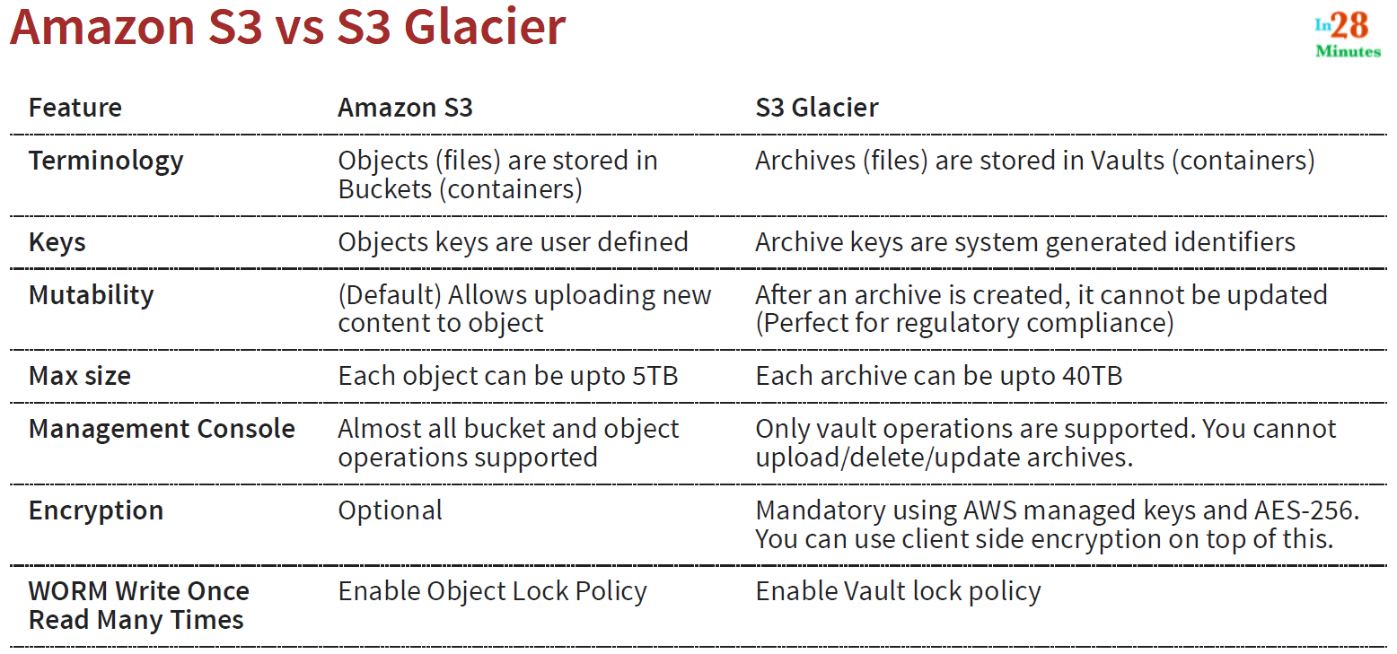

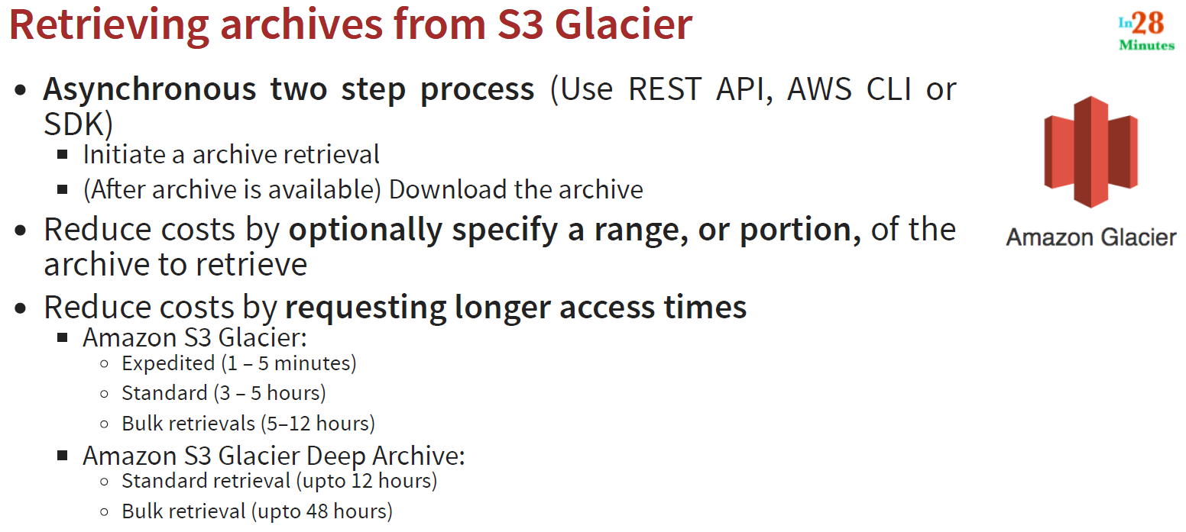

**148. Step 27 - Exploring S3 Glacier - Quick Review**

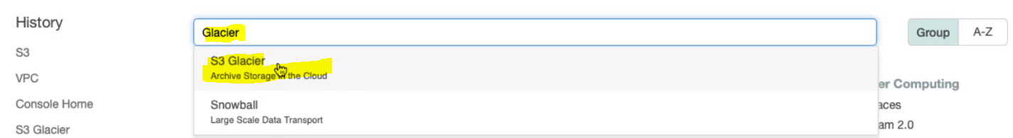

Select S3 Glacier:

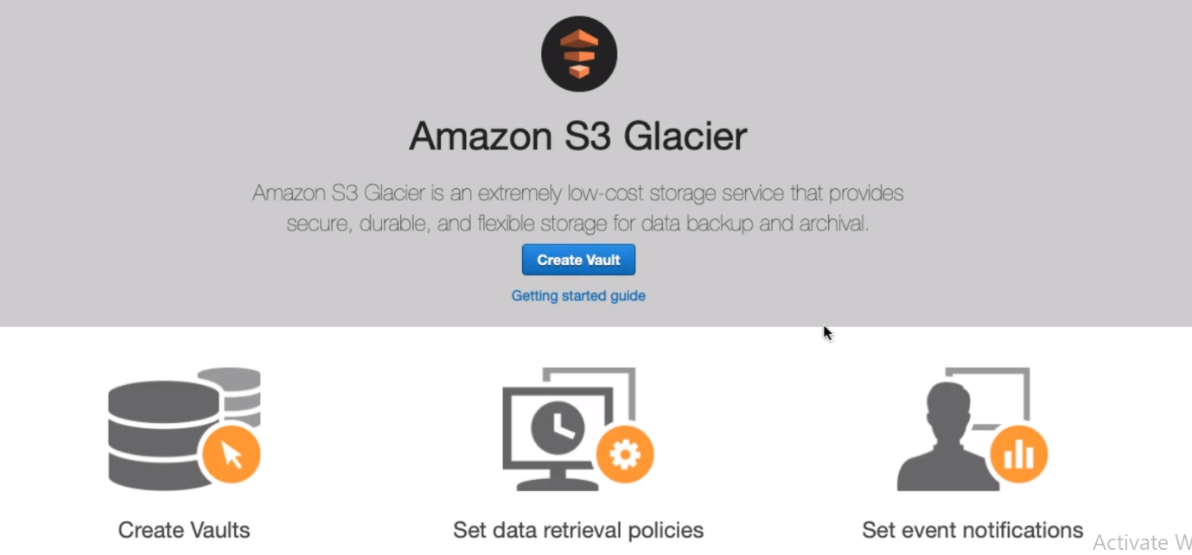

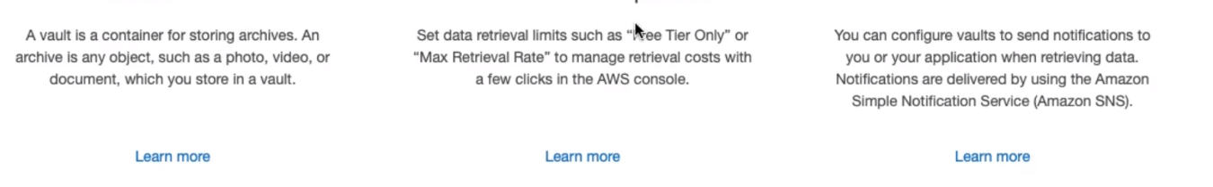

Note : This region specific: So let’s select Mumbai Region:

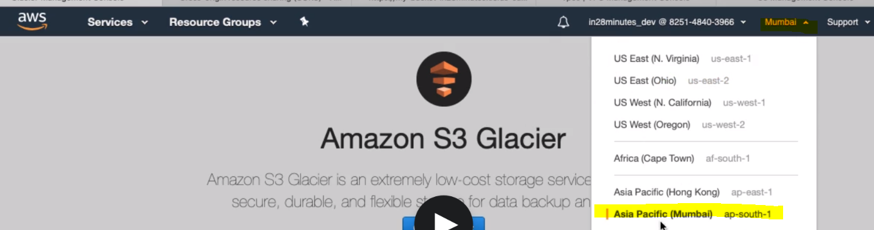

Click on button “Create Vault”

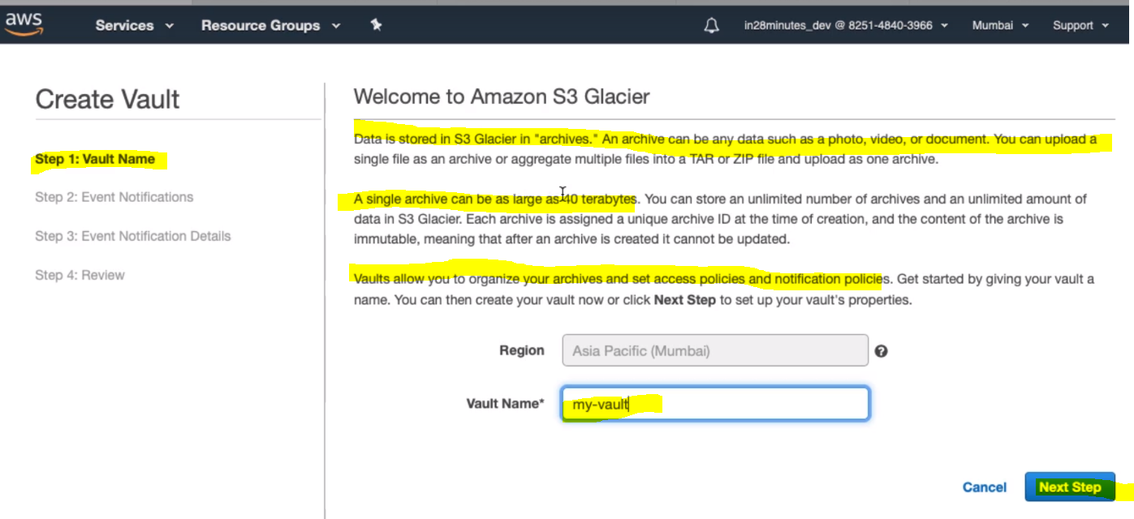

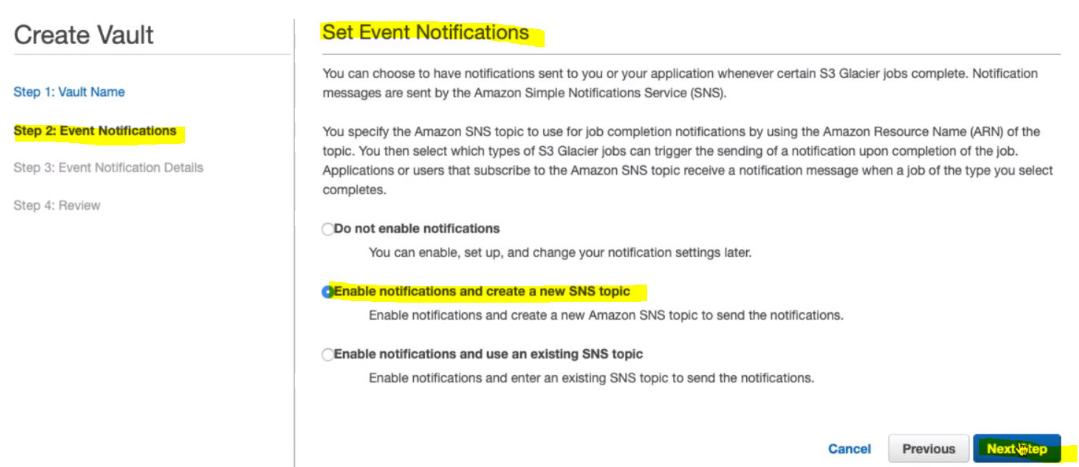

Here in this case it would create notification, that we will not do so let’s choose Do not enable notifications;

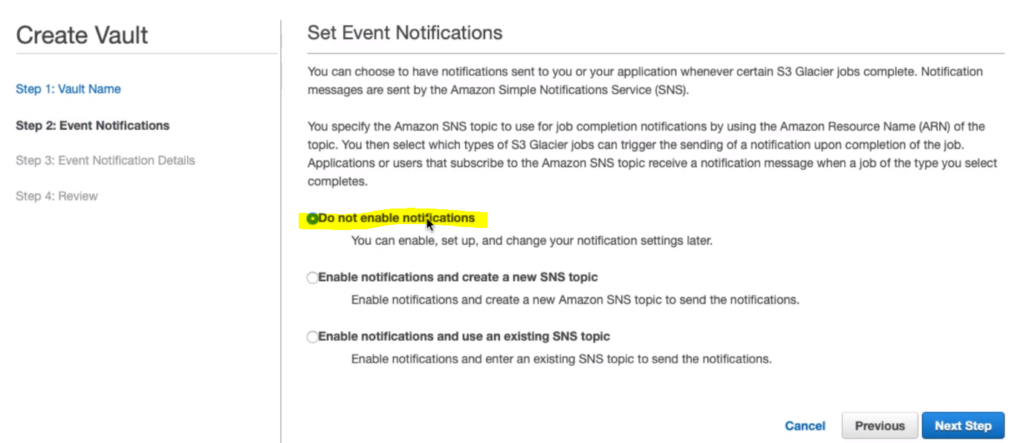

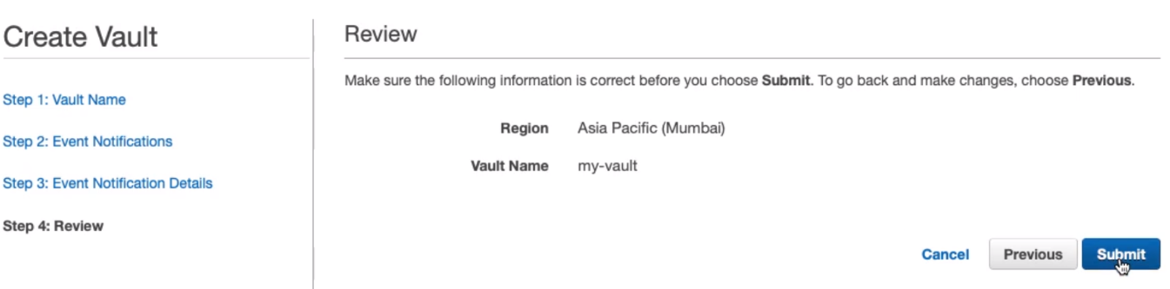

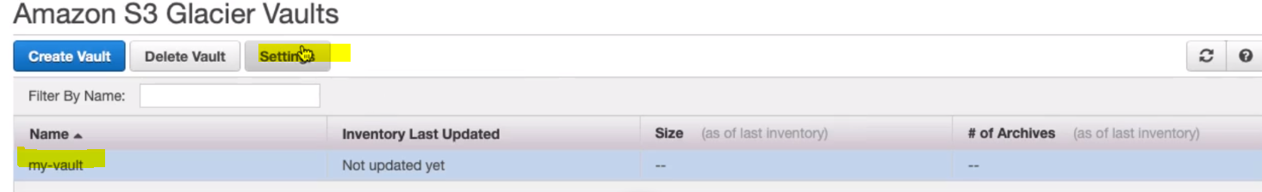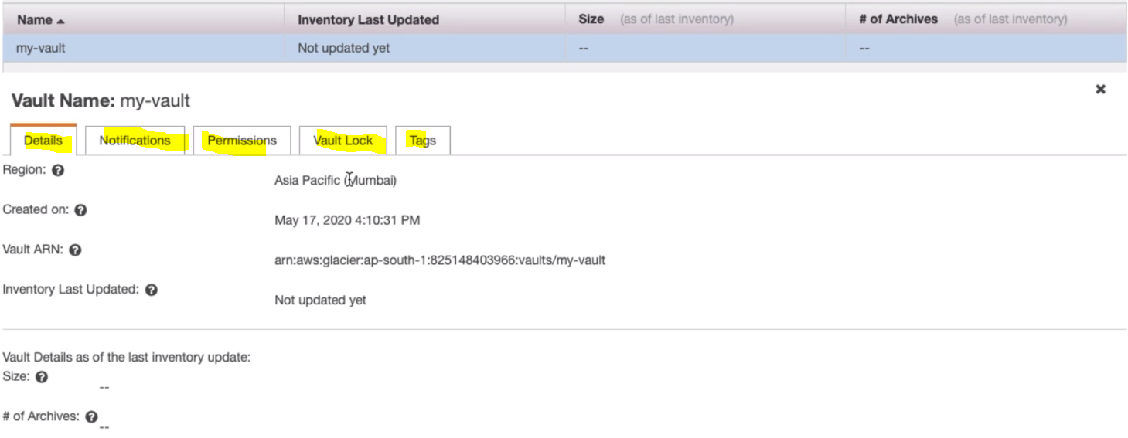

So Vault got created and here we can enable notifications, permissions, vault lock, tags just like normal buckets.

**Go to 🡺Setting Retrieval Policy:**

